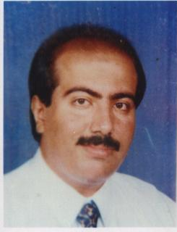
CURRICULUME VITAE

PERSONAL DETAILES :

Name | : Ashraf Helmi Hussein El-Ghonami
Date & Place of Birth | : 10/6/1976 – Al Sharkia
Address | : 399 Gamal Abd El Nasser St., Omar Ebn El-Khatab, El-Nozha El-Gedeeda – Cairo
Telephone | : 0226989861
Mobile | : 0100-1654496 / 0122-1224646
E-mail | : karkar_67@yahoo.com
Material Status | : Married
Gender | : Male
Religion | : Muslim
Military Obligation | : Exempted because I’m single
Nationality | : Egyptian
Driving License | : Saudi Arabia  Emirates  Egypt  England
Car | : Yes

STUDIES :

- B.C. degree in bachelor of Agriculture – may 1989 – General grade Good from the faculty of Agriculture – Ain Shams University .
- Certificate from the International Language Institute (I.L.I) regular English level 14 in September 2000.
- Certificate of professional diploma in Business Administration at Faculty of Commerce – High Studies – Ain Shams University – General grade very good – May 2001 .

SPECIAL COURSES :

- 2 Effective Marketing Skills.
- 2 Effective Merchandising Skills.
- 2 Effective Selling Skills.
- 1 Visibility Manual Skills.
- Meirc Training Development Jeddah.

COMPUTER SKILLS :

- introduction to computer and DOS.
- Windows 98.
- MS-Excel 2000 level 1 and level 2.
- MS-Word 2000 level 1 and level 2.
- MS-Access 2000 level 1 and level 2.

LANGUAGE :

- Arabic : Fluent (Mother Tongue) , written and spoken.
- English : V. Good written and spoken.

WORKING EXPERIECE :

10.02.1985 Till 20.05.1989
Retail Sales reps. In Nestle Co.

01.09.1989 Till 30.09.1992
Retail Sales Supervisor in Kuwait Food Co. (Americana)

02.10.1992 Till 13.05.1996
Sales and Distribution west Area (Geddah – Makkah – Taif)
As Regional Sales Manager in Unilever Arabia Group.

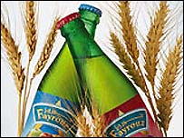
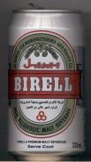
01.07.1996 Till 01.08.2002
Giza Sales Manager in Al-Ahram Beverages Co.

01.09.2002Till 30.11.2005
National Sales Manager in Cadbury-Adams - Libya

01.01.2006 Till 30.12. 2008
Regional Sales Manager Great Cairo In Trade Line For T&D ( SCHWEPPES)

01.01.2009 Till 30.12. 2016
National Sales Manager in ferrero Rocher Egypt KINDER (Bueno-chocolate-joy-nutella-country)
01.01.2016 Till 30.12. 2017
Marketing & Sales Director in ferrero Rocher Egypt

01.01.2018 Till now
Trade Marketing Manager in Dakahlia Slaughterhouses Co.
(Fresh & Frozen products)

