CERTIFICATE DF INTERNSHIP COMPLETION





The College of Clinical Pharmacy Certifies that
HUSSAIN HASHEM ALAWEI ALSADAH
National ID, 11o8186535 a holder of the Bachelor Pharm-D from lITI0m Abdulrahman Bin Faisal University, College of Clinical Phormacy. Has Successfully Completed The Internship Year
from July so'^{h}, 2023 to July 18'^{h}, 2024.
The training was conducted on the following subjects:

Subject (Rotation) | Duration | Training Site
Drug Information | S Weeks | King Fahad University Hospital
Outpatient Pharmacy | S Weeks | King Fahad University Hospital
Internal medicine | 5 Weeks | King Fahad University Hospitol
Inpatient Pharmacy | S Weeks | King Fahad University Hospital
Pediatric | S Weeks | King Fahad University Hospital
Quality Control | S Weeks | King Fahad University Hospital
Drug Information | 5 Weeks | King Abdulla University Hospital
Supply Chain | 4 Weeks | ring Abdulla University Hospital
Community Pharmacy | 4 Weeks | AlDawaa MediCal Services and Co.
Community Pharmacy | S Weeks | AlDawoo Medical Services and Co,


Dean, Col ge of Clinical Pharmacy

PrOf. AsIm A. AI•Ansarl



Vice Dean, Clinical Affairs


Dr. Bassem A. Al-MaIki

Scanned with CamScanner

Issued: | 21/07/2024 | Profile Number: | 23567165
Expired: | 20/07/2026 | Membership Status:

Registration Record
Decision Date Decision type Qualification Country Awarding Date Rank Speciality Sub Speciality



Professional Classification
This certificate is printed electronically ,for verification visit https://www.scfhs.org.sa
21/07/2024
Hussain Hashim A Alsadah
Pharmacist-Pharmacy
Pharmacists and Pharmacy Technicians
Nationality
National/Iqama ID
Saudi Arabia
1108186535
Date of Birth 15/07/2000
Bachelor Degree in Clinical Pharmacy Pharm D

Saudi Arabia 18/07/2023 Pharmacist Pharmacy



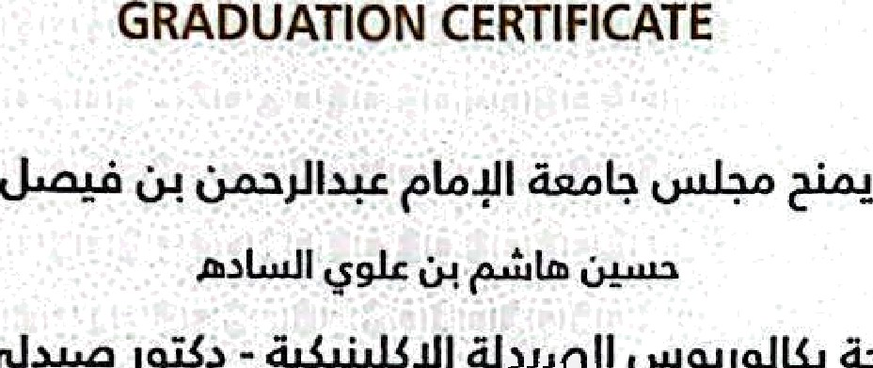

The Council of University of Imam Abdulrahman Bin Faisal hereby confess upon ALSADAH. HUSSAIN HASHIM A
the degree of Bachelor of Clinical Pharmacy - Pharm D

from the College of Clinical Pharmacy
in the 3rd Semester of the academic year Z023

Dean of Admission and Registration


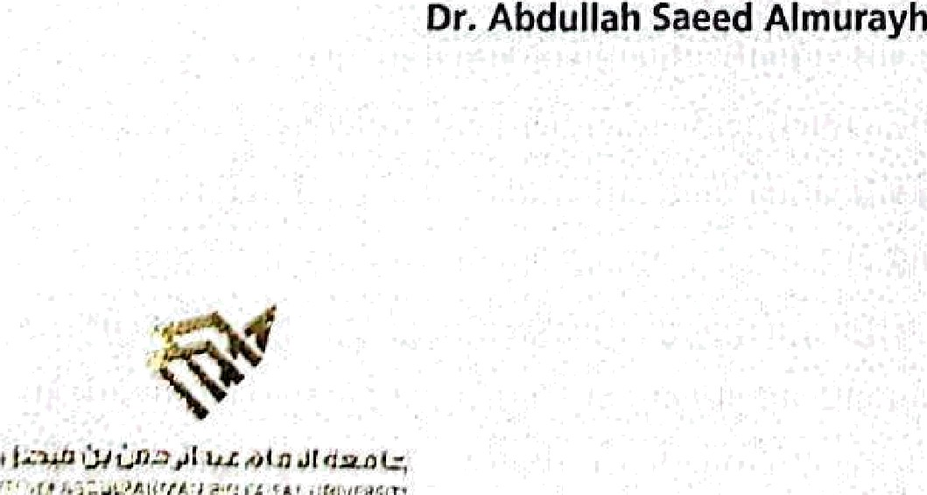


Scanned with CamScanner

