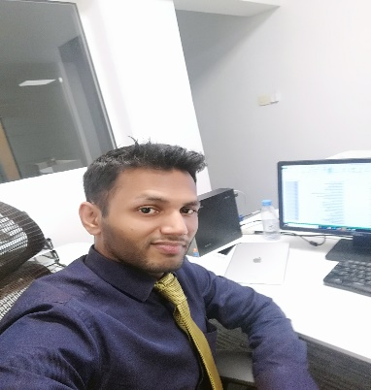

**Exectuve summary**

An astute professional with **12 years** in entire Office Management, Client Relationship Management and Team Management. Currently associated with **Development Styles Corp (Riyadh, Saudi Arabia)** as **Executive Assistant cum Secretary & office Administrator**. Fulfilled all executive assistant duties for four top executives in an international firm. Managed complex calendars, facilitated communication and logistics.



|  |  |  |
| --- | --- | --- |
| **Skill Highlights**  Project management  C-Level Relationships  Office Management  Scheduling  Business support  Executive Support  Document editing  Business Correspondence |  |  |

afzal.mhmmd@gmail.com

Executive Assistant

**Mohammed Afzal Gani**

00966 507814110

Riyadh, Saudi Arabia

**Account Assistant Jan 2014 – April 2015**

**Karvy Stock Broking Pvt Ltd (India)**

* Working with spreadsheets, [sales and purchase ledgers](http://www.totaljobs.com/careers-advice/job-profile/finance-jobs/purchase-ledger-clerk-job-description) and journals.
* Preparing statutory accounts.
* Calculating and checking to make sure payments, amounts and records are correct.
* Sorting out incoming and outgoing daily post and answering any queries.
* Managing petty cash transactions.
* Controlling credit and chasing debt.
* Reconciling finance accounts and direct debits.

|  |
| --- |
| **Hard Skill**  Google Analytics 360  MS Office (Excel, Word, Ms PowerPoint, etc)  Outlook  Tally 9.0 |

**Languages**

* English
* Arabic
* Hindi
* Urdu
* Tamil

**Sr Research Analyst Aug 2011 – Nov 2013**

**Maxval Technologies, India**

* Participated in interaction with US clients for updating work progress, discussing issues regarding data base, suggestions and management, error handling
* Administered process in converting raw data in to processed information and updating the database.
* Provided support for development of project, process flow and training of team.
* Managed project by providing regular solutions and team handling.
* Created project cycle process related documents, Quality report and Log report of the team.
* Acknowledged as the best candidate for planning and development of project cycle. Used research skills for the process and development of Xceligent data base.

**Work. experience**

**Executive Assistant** **Nov 2015 – Present**

**Development Styles Corp (Riyadh, Saudi Arabia)**

* Handing the complete office with all documentation work.
* Supporting tasks and activities to the CEO for achieving target and company goals.
* Organize, Communicate and coordinate the new projects ideas and proposals.
* Manage and Schedule national and international events for CEO.
* Manage special recruitment for the Key positions, based on the requirement from CEO.
* Manage, Schedule and Organize day to day activities in the CEO office.
* Manage, Schedule, and Gather required information in the CEO Office.

**Note: I hereby declare that all the information given above is true and correct to the best of my knowledge.**

**Accomplishments**

* Provided exceptional support to managers and co-workers, increasing the overall efficiency of the office by 30%.
* Trained 15 newly hired staff members.
* Provided backup support to other departments, which was highly admired by the General Manager.

**Academic background**

2011 – **Bachelor’s Degree in Accounting and Economics** - Mumbai University

2007 – **HSC** From Mumbai University, India

2005 – **SSC** From Mumbai University, India

**Accountant Assistant Nov 2010 – June 2011**

**Nj Finance Pvt Ltd, India**

* Documents financial transactions by entering account information Substantiates financial transactions by auditing documents.
* Secures financial information by completing data base backups.
* Serves as the direct link between the advertising agency and the existing client, managing day-to-day affairs and ensuring customer satisfaction.
* Accountancy for the measurement, disclosure or provision of assurance about financial information that helps managers, investors, tax authorities and others make decisions about allocating resources.
* Summarizes current financial status by collecting information; preparing balance sheet, profit and loss statement, and other reports.

|  |  |  |
| --- | --- | --- |
| **View Online CV**  Visit my online CV by scanning the QR code: |  |  |

https://my.cvonline.me/@698bfgvn

|  |  |  |
| --- | --- | --- |
| **References**  Date of Birth : 14th April 1988  Marital Status : married  Nationality : Indian  Religion : Islam  Passport No. : L3612018 |  |  |

|  |  |  |
| --- | --- | --- |
| **Hardware**  Printer  Desktop  Telephone |  |  |



Barcelona

javierablanch@gmail.com

+1 555 555 557