Malik Mohd. Mufizuddin | 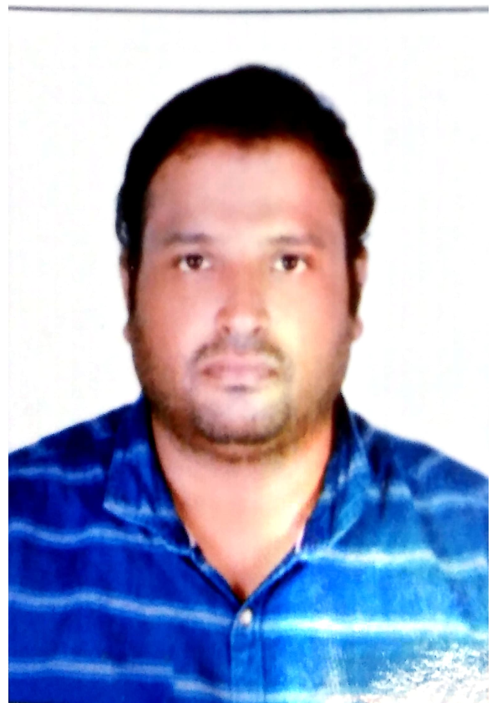ur Photograph |  | E-MAIL mohdmufizuddinmalik@gmail.com  MOBILE +966549132672
Result-oriented and creative professional, targeting assignments in Quality Assurance and Quality Control at Infrastructure Development Project with an organization of high repute in Construction industry.
PROFILE SUMMARY

- A result-oriented professional, offering nearly 15 years of multi-faceted experience; Currently working as QA/QC Manager Civil & Infrastructure with HASCO Ltd.
- Pivotal role in conducting internal & external audits for checking QMS and process effectiveness and formulating Method Statement, Inspection Test Plan (ITP), Project Quality Plan and Quality Control Procedures (QCP)
- Track record of method engineering / method statement development, contract administration and resource planning with a flair for adopting modern construction methodologies in compliance with quality standards
- Proficient in ramping up projects with competent cross-functional skills and ensuring on-time deliverables within preset cost parameters; reviewing drawing, and resolving day-to-day problems
- Thorough in project planning, & technical aspects of projects including implementation, troubleshooting and analysis for improvement
- Skilled in evaluating tenders & competitive bids, analysing technical & commercial deviations from the tender/ bid documents as well as managing the contractual negotiation matters involving rates analysis & pricing strategies
- Collaborated with various statutory bodies for availing mandatory permits as well as obtaining permission for project execution

CORE COMPETENCIES

 | Quality Assurance & Control |  | Project Management - Civil |  | MEP & HVAC Engineering
 | EHS Management |  | Site Management |  | QMS System Implementation
 | Inspection and Testing of Materials |  | Client & Stakeholder Management |  | Team Building & Leadership

SOFT SKILLS  Change Agent  Thinker  Planner  Innovator  Communicator  Collaborator |  | CERTIFICATIONS || LICENSE || EDUCATION  PMP Preparation Course from PMI (February 2021) IS0 -9001-2015 Lead Auditor  Associate Engineer, Saudi Council of Engineers (SCE, KSA)  Bachelor of Civil Engineering from Integral University in 2010  Diploma in Civil Engineering from AMU Aligarh in 2006
CAREER TIMELINE

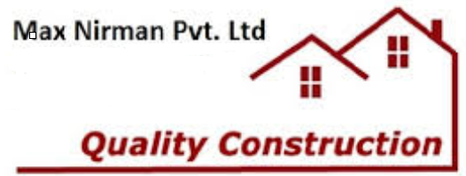

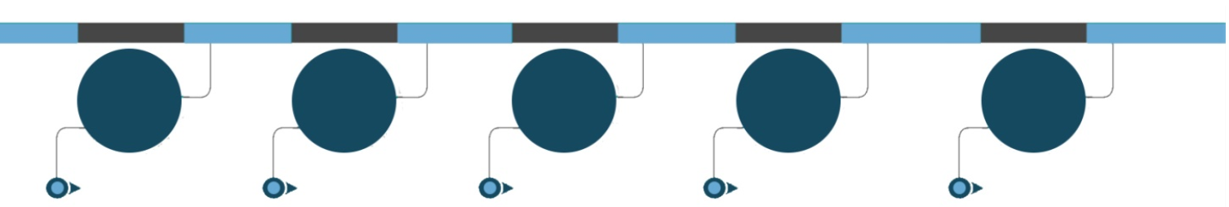
2012-2015
2015-2016
2006-2020
Since 2020
2006-2012

NOTABLE ACCOMPLISHMENTS ACROSS THE CAREER

- Led the timely execution of Housing Project within budget; implemented cost control strategies such as risk reduction & improving supplier quality as well as effective estimates for site infrastructure
- Initiated health & safety guidelines and maintained a safe work place to reduce work related illness & injuries
- Managed construction for Housing projects worth INR 80 Crores / in Lucknow city for Arabic Urdu Persian university
- Provided annual completion equipment and materials technical specifications/quantity requirements as requested by Mr . Bander Al Sehri

WORK EXPERIENCE

Since May’2020: HASCO Ltd., Saudi Arabia as QA/QC Manager Civil & Infrastructure
Amaala Saudi Arabia Projects in Tabuk, Al Wajh & Jizan, Saudi Arabia

Mar’16 - Apr’2020: Nesma & Partners, Jizan as QA/QC Manager

May’15 – Feb’16: Saudi Bin Laden Group - Prophet Holy Mosque Project, Saudi as Civil QA/QC Engineer

Aug’12 – Mar’15: Larsen & Toubro - Construction of 5 star hotel Taj connemara, Chennai as Civil QA/QC Engineer

Jun’06 – Aug’12: ANSAL API Pvt. Ltd. renaissance 5 star hotel LKO Lucknow as Civil QA/QC Engineer

Role:
- Monitoring & controlling projects with respect to cost, resource deployment, time over-runs and quality compliance to ensure satisfactory execution of projects
- Formulating operating budgets and managing overall operations for executing civil projects within cost & time norms
- Organising / participating in project review meetings for evaluating project progress & de-bottlenecking
- Undertaking material receipt inspections at site and inspections at vendors for piping & structural
- Conducting internal audits for checking QMS and process effectiveness
- Implementing quality systems in the organisation to reduce rejections and ensure zero defect products
- Monitoring adherence to quality management system and conduct compliance check with respect to quality frameworks document
- Reviewing the sub-contractor’s procedure, method statement and ITP
- Executing review & submission of pre-qualification & technical documents to PMC for materials approval and material inspections
- Overseeing the site execution of different activities such as Foundations, RCC Works, Finishing Works, and so on
- Inspecting field sites to observe, evaluate condition & operability of facilities & structures, collecting field survey data and measurements
- Formulating & implementing stringent systems and quality plans / manuals to ensure high quality standards during all the stages of project
- Leading a team of QA/QC Inspectors; ensuring suitable deployment and timely availability of manpower (designers & engineers)
- Liaising with clients, architects, consultants, contractors, sub-contractors & external agencies for determining technical specifications, approvals and obtaining statutory clearances
- Demonstrating extensive knowledge and experience in the execution of building works.
- Making project decisions and liaise with applicable authorities.
- Being familiar with the DM General Conditions of Contract, Quality Assurance, Quantity Surveying, and Project Network Techniques
- Demonstrating the ability to prepare instructions, specifications, and reports and cost estimates.
- Reporting on Quality performance at construction meetings.
- Review of all Contractors quality and testing, submissions for contract compliance.
- Carry out surveillance activities on Contractor’s construction activities to ensure compliance
with approved methods/materials.
- Conduct internal training where appropriate.
- Issue regular guidance and information to quality department and engineering staff to ensure
key issues are effectively managed.
- Assist Senior Construction Staff to monitor and close non-conformances

PROJECTS MANAGED

- Amaala triple Bay Early Earth Works
- Ministry of Interior, South Border Housing Complex, Jizan, KSA, Organization: Nesma & Partners Company, H.O, Jeddah
- King Abdullah Bin Abdulaziz’s Project (KAP2A) Riyadh, KSA
- Prophet Holy Mosque Madina
- Construction of IT Building Project, Chennai India
- (G+4) Boys & Girls Hostel Urdu Arabic Persian University LKO
PERSONAL DETAILS

Date of Birth: 25th October 1983
Nationality: Indian
Passport Details: No. L3905622 (Dt. of expiry August 2023)
VISA Details: Saudi Arabia Transferable Iqama
Driving License Details: Valid Saudi Driving License
Marital Status: Married
No. of Dependents: 2
Languages Known: Urdu, English & Arabic
Address: Al Wajh, Saudi Arabia

