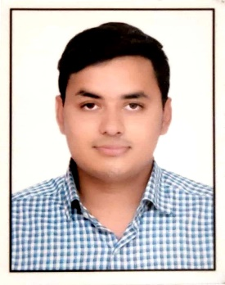
MD DANISH QUAMAR
FATEHGARH
BHOPAL
MADHYA PRADESH
CONTACT NO: 9113493626
mailto: danishquamar26@gmail.com
https://www.linkedin.com/in/md-danish-quamar-0b13591b4

CAREER OBJECTIVE
To develop myself as a professional work driven environment where I can utilize and apply my knowledge, skills which would enable me to grow while fulfilling organizational goals.

BASIC ACADEMIC CREDENTIALS

Qualification | Board/University | Year | Percentage
B. Pharm | RGPV | 2021 | 7.75 CGPA
12TH | BSEB, PATNA | 2017 | 64.6
10TH | BSEB, PATNA | 2015 | 83.8

PERSONAL DETAILS

- Father’s Name :- MD QUAMRUL HODA
- Date of Birth :- 15-06-2000
- Marital Status :- Single
- Nationality :- INDIAN
- Perm. Address :- Vill.- Gadhwa, P.o- Harpur, West Champaran, Bihar
- Blood Group :- B+
- HOBBIES :- Playing Volleyball and Cricket

LANGUAGE KNOWN

S.N. | LANGUAGE | READING | WRITING | SPEAKING
1. | HINDI | YES | YES | YES
2. | ENGLISH | YES | YES | YES
3. | URDU | YES | YES | YES
4. | BHOJPURI | YES | YES | YES

STRENTH

Hardworking, Good Leadership quality, easily adapt to any situation, Always Up to date.

SKILLS

- Basic Computer skills.
- Presentation skills.
- Communication skills

PARAMEDICAL SKILLS

- Blood Group Estimation.
- Hemoglobin Estimation.

DECLARATION

I do hereby declare that the above information is true to the best of my knowledge.

Place: MD DANISH QUAMAR
Date:

