Sandeep N Nair  Quality Engineer |  | 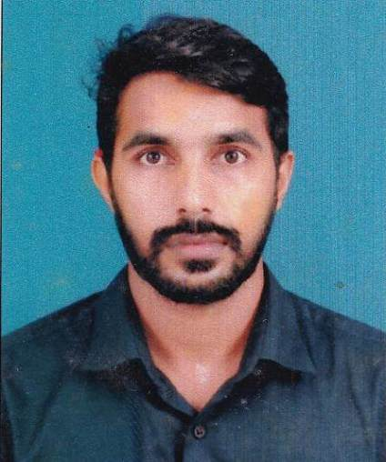
 | ☮Burjuman,Dubai-UAE
 | ☎ +971-588137583
 | ✉ Sandeep.sandeep.nair0@gmail.com
 | linkedin.com/in/sandeep-nair-56b40866

Professional Summary
Quality engineer with 11 years of experience in manufacturing, assembly, Testing & Electrical equipment’s calibration. To help a growing organization develop, and promote superior quality customer service, Negotiation, increase revenue; and develop positive employee relations. Seeking an Industrial Engineering full-time position that will challenge me to use my education, experience, and skills in order to collaborate with the growth of the company and my professional career.
Work Experience

- Joined in Jansal calibration services- Dubai as calibration Engineer from January 2021-Present
- 6+ year and experience in OEN India Limited ,Cochin as Quality/Calibration supervisor(2014-20)
- 4 years of working experience in SFO Technologies, Cochin as an electronic technician(2010-14)

Skills Summary
● | Electrical equipment calibration | ● | IMDS Data uploading | ● | Product Safety compliance | ● | Kaizen
● | QMS Documentation | ● | Product testing-Electromechanical relays | ● | Product compliance certification | ● | Communication
● | PPAP Documentation | ● | Microsoft office, SAP,ERP | ● | Customer Documentation | ● | Problem solving
● | Quality Control Inspection | ● | 5S Methodology | ● | Team work | ● | Process and product validations

Professional Experience-1

From January 2021 to Present Jansal calibration Services-Dubai

Role: Calibration Engineer

- Calibration and testing of all Electrical instruments & Prepare reports

Professional Experience-2
From June 2014 to 2020- OEN India Limited, Cochin.
Role: Supervisor (Executive)

Responsibilities in Testing lab:
- Co-ordinate with team members for customer audit
- Third party product testing- RoHS/REACH
- Product compliance testing -UL /VDE/ LCSO approval of products (Industrial relays)
- Customer Documentation (PPAP,4M Change, CMRT filling , Inspection reports etc..)
- Error proofing techniques, Kaizen, and 5S
Dept: Calibration
Role: Supervisor (Executive)

Responsibilities in calibration Lab
- Experience in calibration of all Electrical & Mechanical instruments

Professional Experience-3

From May 2010 to May 2014 SFO Technologies, Cochin, Nest Group of Company.

Dept: Production
Role: Electronic Technician

Responsibilities:
- Assembling and verification of PCBs for Networking, Medical and Telecommunication (RF) equipment like thermal printers

Personal Profile  Date of Birth : 20 June 1989  Sex : Male  Marital Status : Married  Passport number : S4180536  Driving license number : 40/7569/2010  Languages  Malayalam ●●●●●  Hindi ●●●●○  English ●●●●● | Educational Qualification  Course : Diploma in Electronics Production Technology -First class  GPTC Kalamassery , Kerala, India- 2007-2010  Training Attended  - Basic metrology concept & Uncertainty evaluation  - PFMEA,MSA,SPC,CP, APQP  - Laboratory QMS & Internal audit as per 17025:2017

Declaration

I hereby declare that all the information furnished above is true to the best of my knowledge.

