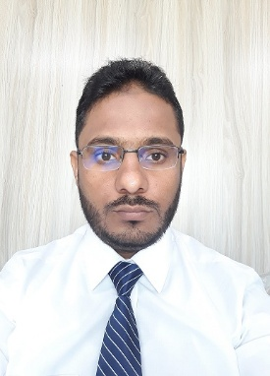
Arslan Javed
Arslanjaved2286@gmail.com
Cell # +92-300-2286337

Objectives:
To work in dynamic environment with growth potential where creative, team spirit, hard work, dedication and sincerity are appreciated, where I can utilize my professional background in all aspects as a contribute to achieve professional goals of my own fulfillment and self-growth.

Work Experience:

4 Year & 08 Month
- Organization: Citi Housing (Pvt) Ltd
Period: 25 November 2019 to Till Date
Designation: Sr.Audit Officer
- Organization: Fri-Chiks (Pvt) Ltd, Lahore &
Rahim Departmental Store, Lahore
Period: July 16, 2018 to 23 November, 2019
Designation: Assistant Manager (Audit & Accounts)

- Organization: Business of Law & Associates, Mian Chanun
Period: January 06, 2013 to April 15, 2014
Designation: Accountant

Job Descriptions:

- Audit :

    - Invoices, Bills, Quotations, Demand Requisitions, Expenditures, Supplies, Purchases, Ledgers, Payable lists, IPC’s, Financial Requisitions, Vouchers and Salaries etc.
    - Physical Inspection at Site / Field in order to Prevent Financial Damages.
    - Stock / Inventory Audited Physically on Monthly Basis.

- Accounts :

    - Checking & Verify of any kind of invoices & Expenses vouchers and posting into accounting Software.
    - Maintain Debtors and Creditors ledger on monthly basis.
    - Prepare monthly Salaries and posting into relevant accounts.
    - Reconcile bank statement on monthly basis.
    - Prepare Profit & Loss statement on monthly basis.
    - Profit & Loss account compare with last months which changes on.
    - Income & Expenditure account compare with last months which changes on.

Certificates:
- 3 Month online Training in “QuickBooks” From Digi-Skills Program Batch-3
- 3 Month online Training in “Freelancing” From Digi-Skills Program Batch-3

Professional Qualification:
- ACMA(Part Qualified) 2015

Academic Qualification:

Master (Accounting & Finance) 2016-2018 Virtual University of Pakistan, Lahore.
B. Com 2010-2012 University of the Punjab Lahore.
I. Com 2008-2010 BISE Multan.
Matric 2006-2008 BISE Multan.

Skills:
- MS Office (Excel, Word)
- Accounting Software (Quick Books, Customized Accounts Management Software online ERP)

Personal Trait:
- Ability to learn things fast.
- Take responsibility, creative.
- Self confident with positive mind set.

Personal Information:
Father Name : Bashir Ahmad
Date of Birth : 06-12-1991
Nationality / Location : Punjab/ Pakistan
Language known : English,Urdu, Punjabi
Address : Mohallah Rehmania St # 1, Tehsil Mian Channu, District Khanewal.

Reference:

Will be rendered on demand.

