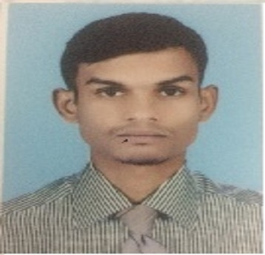
Mohsin Ali
Cell Phone:0545160634 & 0572446932
mohsinoptimistic@gmail.com
Personal details
Profession | Agriculture Engineer
Specialisation | Landscape Designing,Hardscape,Irrigation,Designing of Flower Carpet,Collection of Seasonal flower with respect to time and Location and Creating a Healthly and Pollution Free Enviroment.
Years of prior experience | 07+
Location | Jubail, Kingdom of Saudi Arabia
skills | i) A creative and practical approach.  ii) Design and drawing skills.  iii) Observational skills and an eye for detail.  Iv) IT skills including computer-aided design (CAD)  v) negotiation and leadership skills.
Responsibilities | - Scheduling the work and Assign the task for staff.  - Site Survey and inspection.  - Cellect the observation and resolved.  - Present the proposal for new work and Enhancement.  - Design the irrigation system as per the demand.  - Schedule the irrigation system and control the high Consumption of water.
Summary of experience | - I have worked Water Management Department Sindh in N.P.I.W (NATIONAL PROGRAM OF IMPROVING WATER COURSE) as Site engineer, preparation of Survey, Design & Cost estimate were including in my responsibility (05 January 2012 to 15 March 2015).  - Work as a Site Engineer in MOH (MINISTRY OF HOUSING ) In this project I have different varieties of task like Lining, Excavation,compaction,Pipe lying and jointing Back filling and water supply installation of valve, wiring,Installation of pull box.  - Work as a Site Engineer at King Abdullah Ecnomic.  (V) As a site engineer to build world largest flower carpet  At 11th flower&Garden festival Yanbu at Occational  Park Royal commission Yanbu.  (vi) Work as a Project Engineer at Sabic Petro chemical  company yanbu (April 2017-12 june 2018)  (vi) Worked as Project Engineer in Hadeed Sabic (2018 to 2021).
Trainings | - Complete the SHEMS training for work permit Authorization At yanpet sabic (Yanbu) Authrization No YNC 0707.  - Complete the SHEMS training for work permit Authorization At yansab sabic (Yanbu) Authrization No YAN 00570  Completed many Topic in Daily Tool box meeting  i.e Basic safety,Excavation safety,working at  height,lock out Tag out etc.
Education | Bachelor of Engineer (Agriculture) from Sindh Agriculture University Pakistan
Professional memberships | Registered from Pakistan Engineering Council Rag# 3803
Professional achievements | As a site Engineer to build world largest flower carpet at 11th flower festival at Yanbu in 2017.
Other skills | Computer skills such as Auto CAD, MS Office,
Language | Urdu  English  Hindi  Arabic | Mother tongue  fluent  basic  basic

