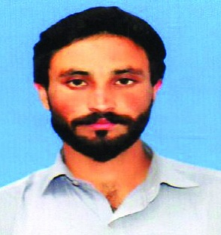
Khiyam Anwar
Address: Poonch Ajk
Contact: +92 314 5282 086
Email khiyamkhan86@gmail.com

To seek challenging position in an organization with an aim to contribute positively towards its objectives to the best knwoledge abilities and skills and to serve with honestly intergrity and diligence with the firm belief that the entity growth and success would be my own.

PERSONAL INFORMATION

- Father’s Name : Anwar Hussain
- Date of Birth : 14/1/1998
- CNIC : 82303-6379799-7
- Passport No : JF1827991
- Gender : Male
- Marital Status : Single
- Religion : Islam
ACADEMIC QUALIFICAITON

- FSc
  - Mirpur AJK
OTHER SKILLS

- IOSH Certified
- OSHA Certified
- NEBOSH Continue
- Basic Computer Application
EXPERIENCE

- 01 Year experience as “Safety Officer” in Bahria Town Pvt. Ltd. Pakistan
- 02 years experience as “Sanitaion Team Leader” in Pakistan
OTHER SKILLS

- Ability to work as team leader and team memebr.
- Good time management skills
- Good learning and implimenting skills
- Good interpersonal skills
LANGUAGES

- English , Urdu, Pashto
REFERENCE

- Should be furnished on demand.

