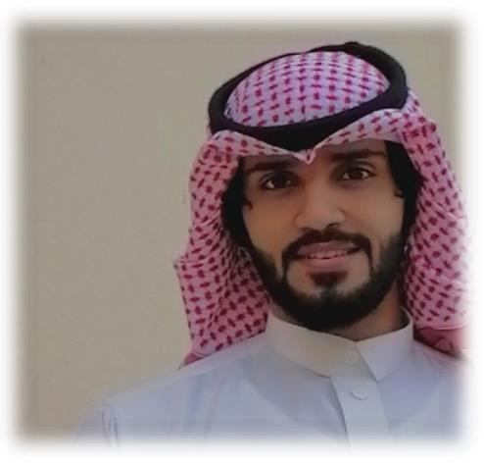
- Quality management in health organizations | dated on | 06/03/22020
- Human Resources Planning | dated on | 06/03/2020
- Administrative coordination | dated on | 06/03/2020
- Teamwork skills | dated on | 04/06/2020
- Life and work skills | dated on | 05/20/2020
- Effective communication with customers  - osha | dated on | 05/06/2020

personal inf

0582048074

FDARRAJ37@GMAIL.COM

27 years old , single

Saudi Arabia,jeddah

Languages

Arabic : Excellent English : intermediate

Proud to be
Work with one team spirit
Collaborate, set goals, and lead a group
Plan
Problem analysis, decision making, project management, strategic planning
Work with one team spirit
Collaborate, set goals, and lead a group

Interests and hobbies
Reading Sports Travel
The Internet Draw

FARIS MOSAAWED DARRAJ
Industrial Engineer
An engineer with a Bachelor's degree in industrial engineering for a period of five years. I aspire to improve my experience in the field of engineering and upgrade my technical and professional experience to learn and grow in my new job in your company.

educational qualifications

2013_2020
Graduate of the College of Engineering - Jazan University Bachelor's degree, industrial engineering

Experiences and skills

- Microsoft software perfect
- Fluent in communication skills
- Careful team management and teamwork
- Effectively solve problems
- Experience in the field of safety (occupational safety and health)
- Call Center Experience (Al Khaleej Company, Smart Link)

training courses

time management

- 40% working
- 15% of the family
- 25% planning
- 10% entertainment
- 10% relaxation

