CURRICULUM VITAE

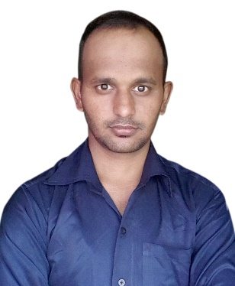
MOHD SHAHBAAZ

PURLIA ROAD, CHANDNI CHOWK, KABIR COLONY,
JAMSHEPUR, EAST SINGHBHUM,
PIN – 832110, JHARKHAND, INDIA

Contact No: +91 – 9931186344
+966- 0566405083
E-Mail Id – mohdshahbaaz65@gmail.com

Sub.: Application for the post of : “MECHANICAL ENGINEER”

CAREER OBJECTIVE

Seeking a positing to utilize skill and abilities in the engineering technology industries that offer security and professional growth being resourceful. Innovation and flexible. Posse’s to ability to learn new and creative things. Always willing accept to challenges contended determination and motivation and motivation. Sincere and motivation sincere and hard worker.

WORKING EXPERIENCE

- Worked with “TARAPORE & COMPANY”, Jamshedpur as an “AUTOCAD DRAFTSMAN” during the session from 21st September 2017 to 07th June 2018.
- Now Continue in Saudi Arabia AMIANTIT.

- I have knowledge about MECHANICAL DRAUGHTING.
- Working knowledge in Autodesk Inventor and AutoCAD Draftsman.
- Develop detailed design drawings and specifications for mechanical equipment, dies/tools, and controls, using computer-assisted drafting (CAD) equipment.
- Experience in 2D DRAFTING & 3D MODELLING.
- Review and analyze specifications, sketches, drawings, ideas, and related data to assess factors affecting component designs and the procedures and instructions to be followed.
- Position instructions and comments onto drawings.
- Check dimensions of materials to be used and assign numbers to the materials.
- Able to conceptualize schematics isometric drawing for mechanical layouts.
- Able to producing Engineering Drawings, with its details.
- Demonstrated competence in Engineering Drawings in Industrial Plant System.

- Knowledge about basic concepts of Q.A/Q.C Inspection definitions / dimension, principles of T.Q.M. Quality Gurus’, Various Costs of Quality.
- Carrying out the inspection before, during and after operations as per relevant engineering drawing, international standard and project specification.

- To assist the Site Superintendent & coordinate the supervisor’s activity, carry out & implement the QA/QC program, arrange & conduct meeting under the Site Superintendent direction.
- Performing Incoming material inspection, verifying vendor’s material certificates in order to confirm as per project specification and relevant International Standards.
- Day to day follow up and Co-ordination with planning, Production & third-party Inspection Agency.
- Witnessing of Mechanical tests.

EDUCATIONAL QUALIFICATION

- Passed Matriculation in the year 2008 from “J.A.C.”, Ranchi.

TECHNICAL QUALIFICATION

- Completed B.TECH “MECHANICAL ENGINEERING” session from 2013 to 2017 from CHENNAI

PERSONAL INFORMATIONS

- Name : MOHD SHAHBAAZ
- Father’s Name : SHAMIMUDDIN
- Date of Birth : 15th January 1993
- Nationality : Indian
- Religion : Islam
- Gender : Male
- Marital Status : Unmarried
- Languages Known : English, Hindi & Urdu

PASSPORT DETAILS

- Passport No. : R - 1904047
- Date of Issue : 01/08/2017
- Date of Expiry : 31/07/2027
- Place of Issue : RANCHI

DECLARATIONS

I do hereby inform that all above information furnished by me are true and complete to the Best of knowledge and belief.

Thanking you,

Date: Yours Faithfully

Place: (MOHD SHAHBAAZ)

