PERSONAL INFORMATION | Name: Abdallah Mohamed sobhy Zaki Elgawish
bb
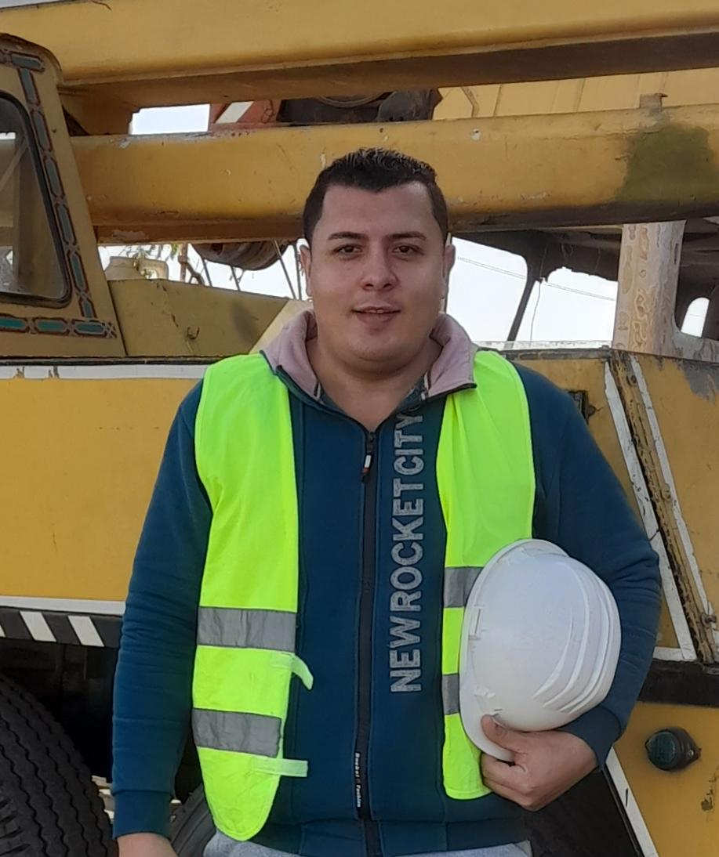 | .Dammam Saudi Arabia
0563002043
Abdogawish978@gmali. Com
 | Marital status: Marriage
Gander : Male
| Date of birth : 20_5_1993
| Nationality : Egyptian

Education:
Faculty of physical education,Tanta University

Military Status : Finished

Position : HSE safety Officer

WORK EXPERIENCE
*Work As HSE Safety Officer In
Orascom construction company in Egypt from 25/12/2019 to 1/3/2022.

Main job responsibilities .__________________________________________________

Responsible for 3 M and E (Man _ Machines _ Materials) and Environmental.

Make (Accident _ Incident _near miss) reports.

Make (daily _ weekly _ monthly ) reports.

Make ( T PT tool box talking _ Induction) .

Responsible for daily permits works.

Make risk assessment for hazard site.

Make warning letter and violations for main company and subcontractors

Achieve our man-hours spent with zero lost time or accidents.

Responsible for developing and enforcing health and safety policies for the project

Ensuring proper safety standards and regulations adhered to for different works

Planning to provide the machine site by safe guards

Familiar with proper hygiene practice.

Confined Space controller_permits _working _finishing.

Recognition the different kind of hazard of work place and its effect on the worker.

Secure the site from the electrical hazard site.

Following the chemical stores and secure.

Trainings And Certification ____________________________________________________________

OSHA GENERAL INDUSTRY SAFETY & HEALTH

OSHA CONSTRUCTIONS SAFETY &HEALTH

Confined Space _ Scaffolding _Inspection of Equipment's _
Fire Pervention_Lifting And Riging_Risk Assessment.

PERSONAL SKILLS ______________________________________________________________

Mother tongue; Arabic
Other language : Einglish | UNDERSTANDING |  | SPEAKING |  | WRITING
 | Listening | Reading | Spoken interaction | Spoken production
 |  | Good | Good | Good
Computer skills Microsoft Office

Organisational / managerial skills | - excellent written and spoken communication skills in order to explain health and safety processes to a wide range of people and to give presentations to groups  - patience and diplomacy because the profession requires a collaborative approach

The original certificates are available

