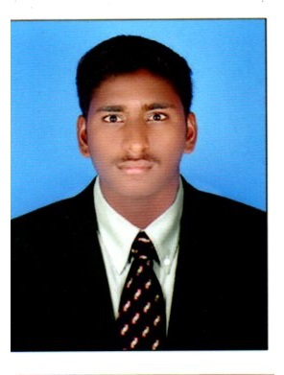

**CAREER OBJECTIVE :** Seeking dynamic and progressive development environment where I can use my knowledge and expertise to continuously grow and learn new technologies in a professional and technical environments.

**INTERNSHIP:**

* **CIVIL INTERN TRAINEE** (1 Month) – **Supreme Infra**, Coimbatore, Tamilnadu
  + Roles and Responsibilities:
    - Site Clearance before the construction starts
    - Implementation of Autocad 2D Plan Design to site
    - Managing Daily Schedule works
    - Site In-Charge for Residential Building work
    - Troubleshooting the issues in work

**PROJECTS :**

* Final Year Project – Development Of Traffic Control And Management System For Kattupakkam Signal
* Mini Project - Planning Analysis and Design of Shopping Complex

**WORKSHOPS:**

* Building Information Modelling
* Survey using Total Station and GIS
* Precast Construction Technology
* Quality Assesment on pavement material and mix design

**AREA OF INTEREST**

* Civil Engineering
* Building Construction
* Site Engineer
* Design Engineer
* Estimation
* Quality Check
* Structural Engineering
* Interior Designing

R. RAJAMANIKKAM

**B.E - CIVIL ENGINEER**

**EDUCATIONAL QUALIFICATION :**

* **2017 – 2021|| B.E/CIVIL**

Saveetha Engineering College,Chennai.

CGPA = 8.2/10

* **2015 – 2017|| 12TH**

Thanthai Hans Rover Higher Secondary School,Perambalur.

Percentage = 92%

* **2015 || 10TH**

Government Higher Secondary School, Venganur.

Percentage = 93.4%

**COMPUTER SKILLS :**

* Auto Cad 2d
* Staad Pro
* Ms Word
* Ms Powerpoint
* Ms Excel
* Basics in C-Programing
* Basics in Python

**PERSONAL INFO :**

* Father’s Name: A. Raja
* Date of Birth: 29/06/2000
* Age: 22 years
* Gender: Male
* Marital Status: Single
* Language Known: English, Arabic Tamil
* Address: Mela Street,Venganur,

Tittakudi Post,Cuddalore 606303. Tamilnadu, India.

**CONTACT INFO :**

MOBILE NO : **0505768280**

E-Mail Id : [**rajamanikkam2329@gmail.com**](mailto:rajamanikkam2329@gmail.com)

**STRENGTH**

* Flexibility – Able to work in a Flexible Manner
* Dedication – I am an Self Dedicated Person
* Positive Attitude –I am able to maintain positive environment
* Creativity - I have creative skills that tends to level up the work
* Leadership – I have tendency to lead the team to the next level
* Determination – I have strong determination to complete the work on the given time.

**WEAKNESS:**

* Tendency to take on too much responsibility
* Organizing work without hesitation

**Hobbies:**

* Playing Cricket
* Playing Kabbadi
* Reading Books

**EXTRA-CURRICULAR ACTIVITY:**

* District Zonal Level Player in KABBADI
* Won Prizes in School and College Sport, Cultural Competitions

**DECLARATION :**

I hereby declare that all the information mentioned above are true and correct to the best of my knowledge.

Place: R.Rajamanikkam Signature