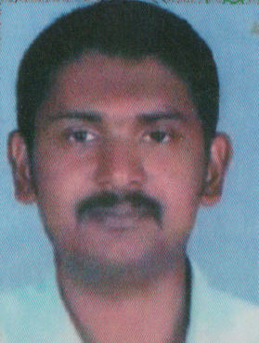
RAZI ABDUL RASHEED
ASEENA MANZIL
SASTHAMPOIKA
THATTATHUMALA P O
TRIVANDRUM
KERALA – 695614
MOb : 9207355672
EMAIL : rasiabdulrasheed248@gmail.com

FATHER’S NAME : ABDUL RASHEED
MOTHER’S NAME : RASHEEDA
DATE OF BIRTH : 07/04/1989
MOTHER TONGUE : MALAYALAM
RELIGION : ISLAM
GENDER : MALE
NATIONALITY : INDIAN
MARITAL STATUS : UNMARRIED
PASSPORT NO : P1596344

LANGUAGES KNOWN
- ENGLISH ,HINDI,MALAYALAM AND ARABIC

EDUCATIONAL QUALIFICATION
- SSLC
- ITC – PLUMBER

EXPERIENCE DETAILS
- 10 YEARS EXPERIENCE IN PLUMBING (UAE,SAUDI ARBIA)

DECLARATION

I HEREBY DECLARE THAT THE ABOVE MENTIONED DETAILS ARE CORRECT TO THE BEST OF MY KNOWLEDGE.

PLACE :THATTATHUMALA RAZI ABDUL RASHEED
DATE :

