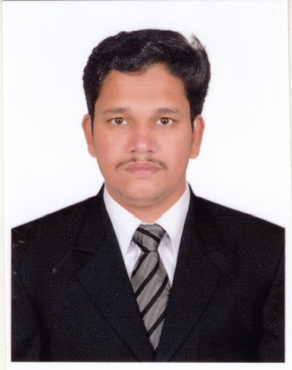 | A.Sadhik ali,  Mobile: 0091-8870781763  Email id: sadhik.cse@gmail.com
Career Objective  9 years of cross-platform experience in service Engineer, including installing, maintaining, and repairing hardware, software, peripherals, and networks. Superior troubleshooting and technical support abilities with migrations, IT support and CCTV Field.  Educational Qualification  Bachelor of Computer Science And Engineering July 2005 – April 2009 (ATTESTED CERTIFICATE IN UAE EMBASSY).  Arasu Engineering college, Affliated Anna University(CHENNAI),Tamilnadu,India  Diploma in Computer Science And Technology June 2003-June 2005  Thanthai Hans Roever Polytechnic College,Perambalur,Tamilnadu,India  WORK EXPERIENCE  - ANANDHAM GARMENTS LTD, KUMBAKONAM INDIA  From Dec 2020 to Till Date as an IT Support AND CCTV ENGINEER  - SADA ALAMMAH COMMUNICATION AND INFORMATION TECHNOLOGY EST in Riyadh, Saudi Arabia  From Feb 2020 to Nov 2020 as an IT AND CCTV SUPPORT  - AL FAHAD SMART SYSTEMS (Abu Dhabi) U.A.E.  From Apr 2013 to Jan 2018 as an CCTV AND NETWORK TECHNICIAN  - VEL TECH UNIVERSITY-CHENNAI  Computer Service Engineer (Sep 2011 to Jan 2013)  - PR COMPUTER CASTLE (INDIA) Pvt..Ltd – CHENNAI  Computer Service Engineer(June 2010 to July 2011)  - Area Of Interest  - Network/System Engineer  - Network Troubleshooting  - Technical Support Engineer  behavioral competencies  - Customer Service, problem solving, integrity and trust.  - Verbal and written communications skills, Listening skills, perseverance, Time management.  - Approachability and Understanding others.  - Team Player and willingness to learn.  Technical Skills  HARDWARE ::  Managing Maintaining a Microsoft Windows Server 2003 Environment (Active Directory, DHCP,DNS & Backup)  Networking - Connecting switches / routers, Access points and providing support to network team while configuration. Remote support using Remote Desktop, and Net meeting.  Configuring & Troubleshooting of mail clients like Microsoft Outlook 2003 and 2007 versions.  Installing, configuring and Troubleshooting Network printers and print servers.  Assembling, Troubleshooting and Maintaining of PCs.  Coordinate with vendors and with company personnel in order to facilitate purchases.  Provide Support in Resolving Networks Problem and troubleshooting of LAN Connectivity issues. Sql, Oracle Database Software Installation, Backup & Restore Software,  CCTV Camera, IP Camera, DVR Installation.  Maintaining and administering computer networks and related computing environments including systems software, applications software, hardware, and configurations.  Performing disaster recovery operations and data backups when required.  Protecting data, software, and hardware by coordinating, planning, and implementing network security measures.  Troubleshooting, diagnosing, and resolving hardware, software, and other network and system problems.  Maintaining, configuring, and monitoring virus protection software and email applications.  Monitoring network performance to determine if adjustments need to be made.  Conferring with network users about solving existing system problems.  Operating master consoles to monitor the performance of networks and computer systems.  Coordinating computer network access and use.  Designing, configuring, and testing networking software, computer hardware, and operating system software.  Design and install well-functioning computer networks, connections and cabling  Perform troubleshooting to system failures and identify bottlenecks to ensure long term efficiency of network  Inspect LAN infrastructure and fix minor or major problems/bugs  Test and configure software and maintain and repair hardware and peripheral devices  Evaluate network performance and find ways of improvement  Organize and schedule upgrades and maintenance without deterring others from completing their own work  Do regular data backups to protect the organization’s information  Provide technical direction to co-workers on computer and network usage and offer comprehensive advice and instructions  SADA ALAMMAH COMMUNICATION AND IT EST - RIYADH  Roles and Responsiblities :  Physical Installation and configuration of IP cameras and access control.  Testing, troubleshooting and maintenance of IP Cameras  Planning IP and Analog cameras configuration  Configuration and troubleshooting of NVR AND DVR  Installation and configuration of IP PBX in Avaya ip office.  ISP and OSP configuration  Fiber optic cable splicing and termination  Configuration of Bio metric attendance system.  Configuration of Intercom systems.  LAN/WAN configuration systems.  Programming for IP PBX systems.  Access control system configuration.  Installation and configuration of telecom network switches.  Maintained the LAN TCP/IP network.  Installed and configured Cisco IPphones, Switches and Routers.  AL FAHAD SMART SYSTEMS -ABUDHABI  Roles and Responsibilities :  Al Fahad Group is a diversified conglomerate with expertise in Defense & Intelligence, Homeland Security, Networking & Communications and Power. Al Fahad specializes in delivering highly tailored, end-to-end solutions to demanding customers across a broad range of industries and government agencies.  From Apr 2013 to Jan 2018 as an IT AND CCTV Support  Project: Abu Dhabi Phase 2.  Key Responsibilities:  - Ability to configure and troubleshoot networking devices (Switch, Routers)  - Calibrating analog IP cameras to achieve the best results to qualify the predefined results provided to us by Third Party Client (UAE Govt(Monitoring and Control center –MCC Project)  - Maintain all team members in supervisor for Installation and maintenance  - preparation of documents and reports for all site activities  - Project executed reported to higher authority.  - Intercom system knowledge of installation and configuration.  - AVAYA IP Phone programming and, configuration knowledge  - Programming and configuring the SVC (Network protocols, UPS.)  - Assured that all CCTV in the facility are running in good.  - Structure cabling in Fiber,copper,Cat 6,Cat 6A,Cat 5 cable termination.  - Project: Abu Dhabi Phase 1.  Roles and Responsibilities :  - Installation and set up of routers and switches  - Responsible for troubleshooting of networking equipment across multiple sites  - Creation and delivery of training materials and support to staff on customer sites  - Configuration of broadband in Etisalat and DU.  - Relevant experience in technology area of emphasis are preferred, e.g. Pelco, Sony, Axis, Hikvision.  - Maintaining check lists, identifying faults and faults rectified by maintenance team.  personal details  Date of Birth : 24 March 1986  Father’s Name : Alavudeen  Marital Status : Married  Known Language : English,Malayalam,Hindi,Urdu,Tamil  Nationality : Indian  Passport Number : M5255886  Passport Validity : 30/03/2025  Present Address : 41 c 1 Pallivasal Street,  Udayar Palayam,  Ariyalur(D.T),Tamilnadu  India-621804.  Declaration:-  I do hereby declare that the above given statements are true and correct to the best of my knowledge. |  | Skills:  Configuration, Troubleshooting, Administration and Maintenance of  Windows 7,8,10  Windows server 2008 &  Windows server 2012.  Certifications  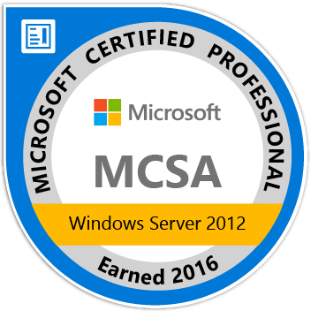Microsoft Certificate Solutions Associate  Microsoft ID:MS0618386984  VERSION: Microsoft windows server 2012  Technical Expertise:  Windows Server2008  Windows server 2012  Troubleshooting.  Switching / Ethernet Technologies  Skills :  Configure and troubleshooting router and switches  install, monitor and troubleshoot network infrastructure products.  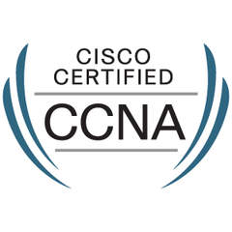  Cisco Certified Network Associate  Cisco ID:CSCO13431015
Place:
Date: (Sadhik Ali)

