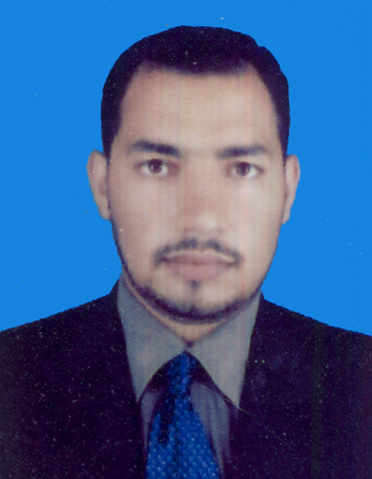
Name: SADAM KHAN Nationality: PAKISTANI
Birth Date, 01/ MAR / 1992,
Address: new city phase 2, wah cantt Islamabad pakistan
Cell. No. +923416951079
(Whats up 00923416951079)
Marital Status: Married
Driving license No: 95280/13
Email: shk.lucky123@yahoo.com

Professional Summary
Health safety and environment officer with more then Four years of industry experience seeks to join a team of focused, motivated HSE professionals committed to improving operational outcomes and company culture through a strategic application of relevant standards, employee training and education, By pinpointing risk scenarios inherent in company processes. Dedicated and driven Safety Officer committed to ensuring the safety and security of the people in the workplace by establishing and providing procedures and policies for a safe environment
Company name
MIE Industrial SDN BHD(Malaysia)

Work Experience (Safety officer) August 2018 – July2021
RESPONSIBILITIES.
- Responsible for monitoring and essessing the hazard and Risk in the work location.
- Implemented new standards and guidelines issued by industry regulators, company managers, and HSE engineers.
- Maintain awareness of active and developing situation.
- Conducted site inspections on a pre-determined basis to ensure the on-going adherence to all applicable standards and regulations.
- Investigate accident that have occurred with in incident area.
- Prepared reports and other documents required by engineers, managers, and regulators.
- Inspect the site to ensure it is a hazard free envirement.
- Conduct Tool Box Meeting(TBM).
- Verify that all tool and equipment are in adoquente and safe for use.
- Promote safe practices at the job site.
- Enforce safety guidelines.
- Training and carryout drill and exercise on how to manage emergency situation.
- Stop any unsafe act or process that seems dangerous or unhealthy.
- Checking the organization rule comply with government rules.

Professional Certificates;
- NEBOSH (International Genral Certificate) UK
- IOSH(managing safely)
- Level 2 Award in Fire and Safety principles
- CIT(Certificate Information Technology)

Computer Skills:
- MS Windows, XP.
- MS Office (Excel, Word, Power Point).
- INTERNET

Language Skills:
- English: Good (reading, writing and speaking).
- Malaysian Malay (reading, writing and speaking).
- Urdu, Punjabi and Pashto.

Education:
- Diploma of Associate Engineer in Electronics 2012, Grade “A”.
- S.S.C. From FG Boys High School Wah Cantt in 2009, Grade 1^{st Division}.

References:
References available on demand.

