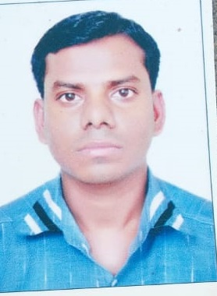
CURRICULUM VITAE
Jitendra Kumar Paswan.
Email Id: jitendrakumar9758@gmail.com
Address: Zamil Coolcare
PO box : 541, Industrial Area
Jizan - 82621

Applied for the post of:
HVAC Service Technician

Areas of Expertise:
- Equipment Installation
- Blueprint Interpretation
- Outstanding Customer Service
- Troubleshooting & Diagnostics
- Electrical & Mechanical Repairs
- Preventive Maintenance & Corrective maintenance
- Safety & Compliance

Responsibility:
- Servicing and maintenance of All types of AC, compressors, evaporators, motors, read and interpret blueprints/diagrams. Installation in split, Ductable, Package units.
- Diagnose electrical and Mechanical fault for HVAC system
- Hand on experience in Compressor Fitting, Leak Testing, Vacuuming, gas Charging etc
- Very good experience and understanding of wiring diagram.
- Performing emergency repairs promptly and efficiently.
- Keeping daily logs and records of all maintenance functions.
- Complying with service standards, work instructions and customers' requirements
- Ensuring compliance with appliance standards and with Occupational Health and Safety Act.

Work Experience: (Total Experience : 8 years 6 month)
- Zamil Air-condition and Refrigeration: Working as an AC technician in MOGS khamis, Saudi Arab Since 7th Oct, 2018 till date.
- Worked as Saudi Manpower Solution : Worked as an AC Technician from 17th Jan 2016 to 16th Jan 2018.
- Worked in Corinthians Club and Resort Pune: Worked as AC technician in engineering department, and responsible for all the services & maintenance. From 14th June, 2013 to 30th Nov, 14
- Worked in as Vignneshwar Air-condition Pvt Ltd. Pune: Worked as a Jr. AC Technician from 4th Oct, 2010 to 4th April 2013

Educational Qualification:

EXAM | BOARD | YEAR OF PASSING | MARKS
S.S.C | Allahabad | 2004 | 52.50%
H.S.C. | Allahabad | 2006 | 60%
D.M.E | Rajasthan | 2010 | 73%

Personal detail :
Permanent Address : At/ Post : Chhittupur,/Bhagalpur Deoria U.P – 274602.
Contact No. :9560799636
Date of Birth : 05/02/1990.
Gender : Male.
Marital Status : Married.
Nationality : Indian.
Languages : English, Hindi.
Passport No. :L8523288

Declaration:
I hereby declare that the above information and particulars are true and correct to the best of my knowledge and belief.

Date :
Place : Jitendra Kumar Paswan

