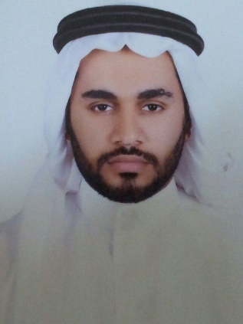 |  | adam abdullah Alzwaid  Senior Purchasing Supervisor
Profile  - Birth Date : April 1985  - Nationality : Saudi  - Martial status : Married  - Al Khobar - Eastern Province  I start working from the age of 17  Trying to find what I want  I love to work in a team spirit. I always strive to develop and get the best  I don’t stop and I will keep going to reach to my goal  Contact  PHONE:  00966 0542458441  EMAIL:  Ada2008m@hotmail.com  Hobbies  Surfing the Web  Playing games |  | WORK EXPERIENCE  GFC food company Senior Purchasing Supervisor  2019-till now  Provides guidance and daily supervision to the team supporting the research, design, development, purchasing and evaluation of training, tools and resources in support of organizational goals, change initiatives and response efforts.  Job Responsibilities:  1. Coordinates and supervises the daily activities of a team, set prioritizes to ensure work is complete. Supervise staff including, but not limited to, hiring, training, coaching and evaluating to ensure a well-qualified team and to enhance operational success.  2. Contributes to the development and implementation of performance improvement products and services.  3. Attain and supervise the human and material resources to support and sustain the efficient delivery of training systems, products and services.  4. Oversee development and delivery business systems to include processes, production and staff performance.  5. Provide mentoring and operational feedback to team members, internal and external stakeholders.  6. Provide guidance and suggestions for performance improvement needs of the organization.  7. Provide support, development and/or leadership guidance to all buyers.  GFC food company delivery supervisor  2015–2019  Ford - Vehicle Delivery Coordinator  2012–2015  Supervising the receipt of cars, clearance, processing and delivered to branches  McDonalds -Restaurant Manager  2005–2008  From working as crew to crew trainer to crew chief to manager  my responsibility was taking care of staff a store needs and deliver customer satisfaction  EDUCATION  Alkhazamaa High school  2016 – 2019  I have many experience certificates from different places  training courses  - Basic management training  - Practical shift management workshop  - Service expert course  - Customer service workshop  - Basic food hygiene class  - Coaching workshop  - Service food safety certificate  Language :  I speak good English…. I Writing & Reading  Skills  Teamwork spirit

