RESUME

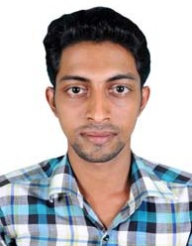
HARIS P A

Poovathumkadavil House Kottanellur P.O
Pattepadam, Thrissur District, Kerala, India - 680 662

Mob : 0091 6238575866
Email : harisabdllatheef@gmail.com
Passport No: U8354767
CARRIER OBJECTIVE:
To be able to secure a good career in a well establishment organization that will help me to grow and give me a chance to show my capabilities.
PERSONAL PROFILES :
Name : HARIS P A
Father’s Name : Abdul Latheef
Date of Birth : 12-05-1990
Nationality : Indian
Aadhar No. : 728243278865
Gender : Male
Religion & Caste : Islam, Muslim
Marital Status : Single
Languages Known : English, Malayalam, Hindi, Tamil, Arabic

EDUCATIONAL QUALIFICATION :
- PlusTwo (Completed) Kerala HSE

LICENSE DETAILS :
- Light & Heavy with Badge
License No. : 45/5948/2008
WORK EXPERIENCE (TOTAL 12 YEARS IN AND ABROAD INDIA)

- Working as a Driver (Light & Heavy) in Kerala
- 5 years worked as a Driver (Light) at Saudi & Qatar

DECLARATION
I hereby declare that the above mentioned statements are true & correct to the best of my knowledge and belief.

Place : Pattepadam HARIS P A
Date :

