CURRICULUM VITAE

HASEEB AHMED
Al Adamah, Dammam
Kingdom of Saudi Arabia Mobile: +966 582033689
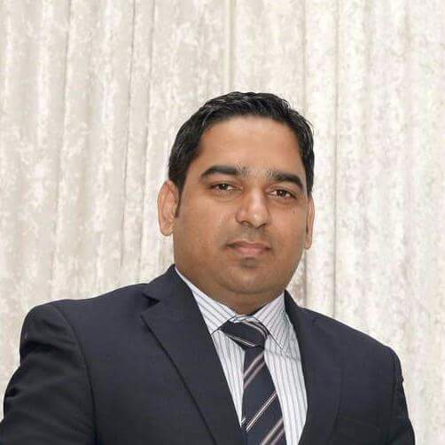
Email : Haseebjz007@gmail.com

Position Looking For
    - Logistics/Transport coordinator
    - Public relation coordinator/customer representative.
    - Office Administrator
    - Project Coordinator
    - General Services Coordinator

Personal Details
Age: 28
Nationality: Pakistani
Gender: Male
Marital Status: Married
Iqama Status: Transferable
Driving Skills: Valid Saudi Driving License

Working Experience: 7 years (Saudi Arabia & Bahrain)

Employment History

JACOBS ZATE Consulting Engineers (Saudi Arabia)
International Company for Energy, Chemical & Resources (ECR)

- Position Title: Logistic Coordinator
- Position Level: First
- Specialization: Operations/Admin/Customer Service
- Industry: Oil and Gas
- Date Joined: March 2018 to till date

Job Description:

- Planning logistic schedule
- Scheduling and forecasting drivers for package delivery, executive management trips with Saudi Aramco and clients.
- Routine communication with project engineers/project Admin for logistic arrangement throughout Saudi Arabia and Bahrain.
- Ensuring package delivery to Site offices/client offices in Saudi and Bahrain.
- Checking postal services on regular basis on Saudi Post.
- Tracking Pool vehicles and scheduling vehicles for site trips
- Scheduling vehicle maintenance. (minor/major services)
- Maintaining proper documentation and filing for records
- Ensuring SAFE PALN OF ACTONS/JOURNEY MANAGEMENT PLANS for site/business trips
- Reviewing and evaluating the SAFE PLAN OF ACTIONS /JOURNEY MANAGEMENT PLANS before escalating to HSE depts.
- Coordination with HSE for site trips and road safety policies.
- Monitoring weather reports, road blockades or diversions before site trips.
- Registering and monitoring in vehicle management system and GPS equipped on the vehicles
- Inspecting and routine checkup of vehicles.
- Updating and recording fleet details on Vehicle Management Systems.
- Updating and recording vehicle inputs on JESME Jacobs Internal software. (Jacobs Employee Service Middle East)
- Processing Bahrain permits for Western and Bahrain residing contractual employees.
- Arranging Executive management meeting with Saudi Aramco.
- Monitoring Aramco client vehicles safety requirements.
- Arranging accommodations/housing facilities for western employees and for visitors.
- Processing Aramco ID and vehicle stickers and communicating with Aramco customer representatives for completing the required tasks.
- Scheduling/Arranging Defensive Driving Courses for eligible engineers conducting site trips with Aramco clients.
- Checking and tracking traffic violations.
- Contacting and communicating with international visitors for mobilizing (airport/housing assist) to kingdom.
- Routine touch with the lease agencies on lease contracts on mobilizing and de-mobilizing housing and vehicle lease contracts.
- Liaise with the agencies to fulfil the company requirements.

Jadeer Gulf Trading Services (Saudi Arabia)
Supplying the vehicle for lease/rental for Major companies in Saudi Arabia.

- Position Title: Operations Fleet coordinator
- Position Level: First
- Specialization: Sales & Vehicle Fleet Management coordinator.
- Industry: Automobile & vehicles
- Date Joined: September 2014 to March 2018

Work Description:

- Maintaining relation with the clients
- Ensuring Vehicle delivery on time.
- Controlling and handling major issue such as breakdown, services and vehicle maintenance with the client vehicles.
- Follow up for the payments.
- Enlisting forecast of Mobilization of vehicles and release of vehicle contracts.
- Furnishing and processing paperwork’s such as insurance, permits, registrations, delivery notes and authorization letters related to vehicles
- Tracking and monitoring lease vehicle contracts
- Liaise between the clients and getting feedback monthly on the services.
- Floating Purchase Orders and processing documentation.
- Customer payment control and payment release processing.
- Updating of customer payment and pending dues.
- Updating account report to Account manager.
- Making Quotations for customers.
- Attending Meetings with international customer & companies.
- Providing over all vehicle services to clients in Saudi and Bahrain.

Educational Background

Level | Year | Institution
SSC (Science) | 2011 | Board of Intermediate Secondary Education (RWP) Pakistan
MS OFFICE  ADVANCE | 2013 | Sindh Board of Technical Education  (SBTE) Karachi Pakistan
DIPLOMA OF ASSOCIATE ENGINEER (AUTOMOTIVE) | 2014 | Sindh Board of Technical Education  (SBTE) Karachi Pakistan (3 years)

Computer Qualification

- Qualified advance computer courses as per below details.

Top Skill
Skill | Proficient
MS Office | Advance
Ms Outlook | Advance
MS Excel, MS World | Advance
Web Browsing | Advance

Languages

Proficiency (0=Poor – 10=Excellent)
Language | Spoken | Written
English | 10 | 10
Urdu | 10 | 10
Arabic | 10 | 9

Additional Info:

Career Objective:

To pursue profession in any field especially interested in Accounts and administration which provide me bright future, aiming the good position by making use of my previous experience, and fulfilling the expectation of the company in a profitable way.

Capabilities:

- Optimistic Attitude can handle any type of situation in Assertive manner.
- Regular Up gradation.
- Fast grasping of different management skills.
- High integrity and self-respect.
- Ability to work under stress.
- Ability to produce positive results consistently.
- Efficient, hardworking and cooperative.
- Fast Learner Ability to work in a team as useful member of that team.
- Ambitious and energetic.
- Capability of good public relations.
- Ability to work in multinational environment.
- Ability to work for long & flexible hours if required.

References:

- All reference will be provided upon request.

