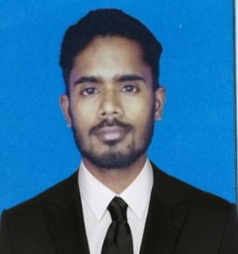
CURRICOLUM VIATE

MOHAMMAD NEHAL HASAN

Mobile: +966571902374

E-Mail: nehalhasan307@gmail.com
Post Applied for – BMS Operator

PROFILE

An BMS Operator with 5+ Years of Experience in Building Management System facilities in Saudi Arab and India. Currently seeking a position to utilize my skills and pursue a highly challenging Career in and esteemed organization.

EDUCATION
- Diploma in Electrical and Electronics Engineering Bangalore (Karnataka)

SOFTWARE SKILLS

- BMS Trend : Siemens, Honeywell and Yokogawa
- MS- Office-Packages : Word, Excel& Power point

WORK EXPERIENCE

- BMS Operator Al Medina Hospital Through Samama Operation & Management from February 2019 to Till Now.
- BMS Operator Al Dana Capital Security and Safety Bahrain from February 2018 to November 2018.
- ELV Supervisor ELMATICS ENGG PVT LTD India from September 2015 to January 2018.

ROLE AND RESPONSIBILIES

- Monitor and control Building integrated Systems including of BMS:-Hvac Controls,Fire Alarm Systems, CCTV, Lighting Control,PAS,IAS, Access Control System.
- Testing and commissioning of BMS DDC Panel Controllers and field devices.
- Preventive maintenance for the DDC Panel, Controller, Modules and field Devices Like:-(Honeywell) XL-50, XL-10, Actuators, Sensors, Transducer and (Johnson Control) CK-721,RDR2S-A,Card Readers, IP camera etc.
- Monitoring Alarms/Events and insure that the System working properly and efficiently.
- Take Corrective Actions to the rectify any Malfunction in the Systems.
- Technical Services and Operation Maintenance for the BMS/ELV Systems.
- Day to Day Maintenance and Technical Support of site including Suggestion Solutions and Analyzing requirements to meet users’ needs. Maintain Daily readings, Consumption and help Desk.

WORK ON BMS HVAC SYSTEM

- Chillers
- Package Units
- AHU'S
- Fan Coil Units
- Split Units
- Ductable Split Units
- Exhaust Fan
- Fresh Air Fan
- Variable Air Volume
- Fire Dampers
- Motorized Smoke Fire Dampers

LANGUAGE PROFICIENCY
- English,Arabic, Hindi, Urdu.

COMPUTER SKILLS

- MS OFFICE,

PERSONAL DETAILS
Date of Birth : 15 June 1995
Marital Status : Single
Sex : Male
Nationality : Indian
Pass port Number : P1689512 (Expiry- 17/10/2026) Place of issue Patna Bihar India.

DECLARATION
I do here by declare that the above statements are true to the best of my knowledge and behalf
Of,

Mohammad Nehal Hasan

