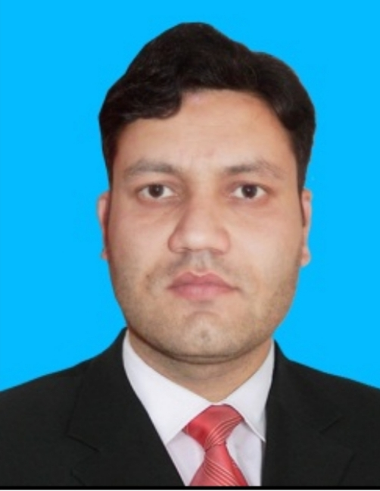 |  | Muhammad Sharif
Profile  Graduate in Pharm-D from Abasyn  University Peshawar, Pakistan.  Self-motivated, Hard Working, Possessing good conceptual and creative skills, approach and implement projects systematically and in a disciplined manner and good communication skills.  Nationality  Pakistani  CNIC  15502-0743691-1  DOB  24-08-1996  ADDRESS  Besham District Shangla KPK, PAKISTAN  Contact  PHONE:  0312 5934576  EMAIL:  Beshamian12@gmail.com |  | EDUCATION  ABASYN UNIVERSITY PESHAWAR  PHARM-D  2015 To 2020  SCFH LICENCED PHARMACIST 2023  BESHAM MODEL SCHOOL AND COLLEGE  FSC  Pre Medical 2015  MATRICULATION  2012  WORK EXPERIENCE  INTERNSHIP HAYATABAD MEDICAL COMPLEX PESHAWAR(HMC)  10-2020 To 12-20  Hospital Pharmacy And Medicine Dispensing To In patient Dept.  Davis Pharmaceuticals Islamabad [Production Pharmacist]  02-21 To 12-2021  REGULATORY AFFAIRS OFFICER FAZAL PHARMA (PHARMACEUTICALS AND CONSUMER)  1-2022 To Present  Professional SKILLS  - Counselling Excellent  - Retailing Excellent  - Marketing Excellent  - Production Excellent  - Distribution Excellent

Languages
- ENGLISH
- URDU

