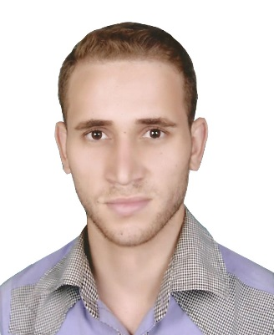
Egypt El-Menoufia
Home : 0482295515
Mobile : 01555450828
E-mail:hamdyelwakdy@gmail.com
Hamdy Ibrahim Abd El-Hamid
Personal Data
- Date of birth : 3 / 2/ 1990
- Nationality : Egyptian
- Military service : Done
- Marital status : Single
Objective
Seeking for a job as a pharmacist in your hospital
Education
- Bachelor of Pharmacy from faculty of Pharmacy – Cairo University at June 2012
- Diploma of Clinical Pharmacotherabyfrom Scientific Arabian Academy from
22 / 12 / 2013 to 31 / 01 / 2015 certified from Xbridge Academy
Courses
- Practical applications of selling and marketing skills for pharmaceutical products ( SMS ) from ICC ( International Culture Center )
- Emergency & First Aid Course from ICC
Training
- Magdy pharmacy Jan. to Sep. 2011
- Training in One day surgery hospital Basitin
Extra-Curricular Activities
- Member of ( The way to Nobel ) magazine in Cairo Pharmacy
- Member of ( Clinical pharmacy family ) in Cairo Pharmacy
- Member in ( Drug Profile Project 2010 ) about BUDESONIDE organized by Faculty of Pharmacy – Cairo University
Experiences
- One year experience at Matrouh military hospital
- Two years experience at El-Nahas Pharmacy from 1/8/2012 to 1/8/2014
- Pharmacist at Menouf hospital from 5 / 12 /2013 till 4\2015
- Pharmacist at EL Shaimaa pharmacy from 15\8\2014 till 3\2015
- Pharmacist at Aldwaa pharmacies at Dammam city from 27/5/2015 till 16/11/202

Languages
Arabic : Native
English : Very Good
Computer Skills
- Good knowledge about Microsoft Office Suite
- Very Good at Internet

