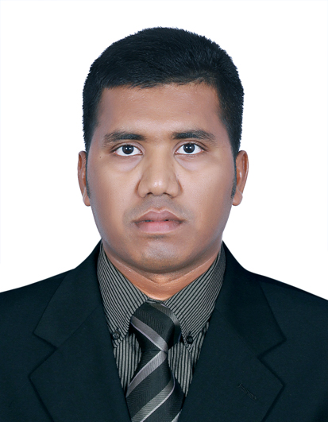**MD RASEL**

Mobile : +8801319072140

Email : shahadathhossain01sh@gmail.com

Skype : Md Rasel

Linkedin : <https://om.linkedin.com/in/md-rasel-800043136>

**Career Objective:**

Ability to take the challenge of working in a highly professional environment that I am able to present positive opportunity for intellectual, personal and financial growth.



**Professional Work Experience:**

**Lifeguard**

**Sheraton Grand Macao Hotel (Marriott)**

**Macau China (September 17,2019 - October 14,2020)**

* Ensuring patron’s safety.
* Implement safety control measures.
* Observe and predict unsafe conditions for residents and staffs.
* Performs a wide range of rescue work depending on the situation.
* Performs injury prevention and safety.

**Lifeguard (Licensed)**

**Shangri-la Barr Al Jissah Resort & Spa**

**Sultanate of Oman (September9, 2016 to September 30, 2019)**

* Ensuring patron’s safety.
* Implement safety control measures.
* Observe and predict unsafe conditions for residents and staffs.
* Performs a wide range of rescue work depending on the situation.
* Performs injury prevention and safety.

**Health Club Attendance&Service**

**Shangri-la Barr Al Jissah Resort & Spa**

**Sultanate of Oman (December 20, 2014- September 8, 2016)**

* Greet everyone who comes in the front door.
* Check in members and verify membership.
* Register guests and collect guest information.
* Register prospects and channel them to the membership department and Provide directions.

**Academic Background:**

**H.S.C. (Higher Secondary School Certificate)**

FaridgonjDegree College

Year completed: 2008

Group: Business Studies

**S.S.C. (Secondary School Certificate)**

Kalir Bazar M R High School

Year completed: 2006

Group: Business Studies

**Skills:**

**Language skill**

English (Full professional proficiency), Bengali (Native), Arabic (working Proficiency), Hindi (Working Proficiency)

**Computer skill**

* MSWord, MS Excel
* PowerPoint

**Personal Information:**

Nationality : Bangladeshi

Birthdate : January 1, 1991

Passport No: BN0337918

Religion : Islam

Height : 5’10”

**Training Courses Attended:**

**Lifeguarding/First Aid/CPR/AED**

American Red Cross Certification

September 9, 2016 -September 9, 2018

**Lifeguarding/First Aid/CPR/AED**

American Red Cross Certification

February 05,2018-February05, 2020

**Shangri-la Care**

Shangri-la Hospitality

January 12, 2015

**CPR. AED & FIRST AID**

MEDIC FIRST AID

November29, 2020-November 29,2022

**Strength & Abilities:**

* To be able to work under pressure, for long hours in a heated environment.
* Have the ambition to learn and implementing knowledge gained.
* Shows willingness to work, learning everything possible during the period of employment.
* Ability to work according to hours required and able to lead the team.

**Hobbies:**

Reading Books, Travelling, Playing Football, Swimming.

I, **Md Rasel**, hereby declare that, the above mentioned statements are accurate and exact.