Abid Farooq | 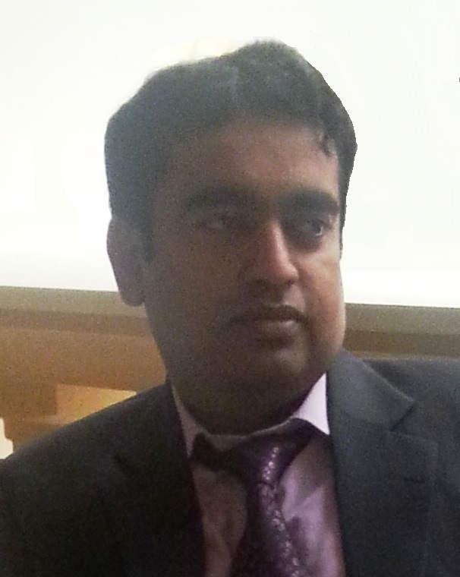   +966546401808  Email:abidfarooq187@gmail.com  Riyadh, Saudi Arabia

Job Vision  Professional Experience summary | • 17+ year experience To explore my energies and talent for achieving self realization, to satisfy appetite for challenges and considerable practical experience across the finance function, particularly in financial accounts, development & re-engineering of systems.  • To contribute towards the growth and development of a dynamic organization where opportunities to grow both professionally and personally are ample.  • To keep in touch with the new developments in the professional arena of business, finance and systems integration.  • Chief Accountant  1 Year Assas Accounting Software  Watad Investment Company. Riyadh KSA  (October-2021 TO Current.)  • Chief Accountant  +6 Years – Tally ERP 9  COLSA GLOBAL ARABIA. Trading Company. Riyadh KSA  (March-2015 TO September 2021.)
• Senior Accountant
+5 Years – MS Dynamic GP & AX 2012
ROLACO GROUP. Jeddah KSA
(MAY-2009 TO March 2015 )

- Accountant
4 years – ERP -GL MODULE)
AHMAD FINE TEXTILE MILLS LTD./FAZAL REHMAN FABRICS LTD. (ENTITIES OF FAZAL GROUP MULTAN-PAKISTAN).
(December 2004 to October, 2008)
Academic Qualifications | - Master of Commerce  Bahauddin Zakariya University, Multan Pakistan in 2005  - Bachelor of Commerce  Bahauddin Zakariya University, Multan Pakistan in 2002
Specialties  Activities and interests |  | - Worked in Cranium, Oracle financial, Tally ERP 9, Microsoft Great Planes AX & Assas Software. Proficient in the usage of Microsoft Office (especially Excel and Word)  - Mountaineering, Tracking, Playing cricket and Badminton
Personal |  | - Father Name: Muhammad Farooq  - Date of Birth: August 10, 1982  - Nationality: Pakistani  - Iqama Status: Transferable  - Marital Status : Married
Professional experience
• Financial and Strategic Planning
• P&L Management
• B/S Management
• Auditing and Compliance
• Costing & Reporting
• Operating and Working Capital
• Loans Rescheduling as per Market Trends and internal structure
• Contracts and Leasing
• Budget Development and Management
• Cash Flow Management and Modeling
• Management Reporting & Analysis
• Income Tax, Withholding Tax & Value Added Tax Compliance
• IFRS Compliance endorse by SOCPA

My Responsibilities had been:
FINANCIAL ACCOUNTING AND REPORTING
a) To ensure Smooth & timely closure of books. Timely submission of review reports, trial & miscellaneous reports required by the management.
b) To ensure compliance with IFRS requirements endorse by SOCPA.
c) To prepare monthly profit & Loss and Balance Sheet and other financial reports as required.
d) To prepare monthly, quarterly and yearly reports for the management
e) Liaison with the internal and external auditors
f) To Prepare Income Tax, Withholding Tax & Value Added Tax Return.
g) To check and review balance sheet reconciliations prepared by different departments.
h) To prepare variance analysis of the Profit & Loss of the company.
i) To ensure that Inter-unit/Intercompany reconciliations are prepared timely and all necessary entries are incorporated before preparation of monthly accounts

