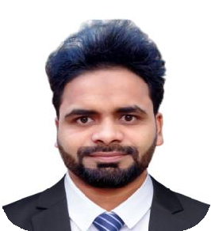 Curriculum Vitae
ALTAF HUSSAIN
CAREER OBJECTIVE
Self-motivated and
hardworking fresher seeking for an opportunity to work in a challenging environment to prove my skills and utilize my knowledge & intelligence in the growth
of the organization.
CONTACT DETAILS
Mobile No. 9368959058
Email id. hussainaltaf9756@gmail.com
ADDRESS
VPO JARAUDA DIST. MEERUT, UTTAR PRADESH

PERSONAL DETAILS
AS

Date of Birth | 05-07-1996
Father's Name | ASHFAQ HUSAIN
Mother's Name | NASREEN FATIMA
Nationality | INDIAN
Marital Status | Unmarried
Language | ENGLISH ,HINDI , URDU
Hobbies | BOOK READING, & LIKE TO CRICKET
PASSPORT NO. | U4288147
DATE OF ISSUE | 19/03/2020
DATE OF EXPIRY | 18/03/2030
ACADEMIC QUALIFICATION
EXAM NAME | Board /  University | Passing year | Percentage  of Marks | Division
10th | UP BOARD | 2011 | 45.00 | 2nd
12TH | UP BOARD | 2013 | 63.50 | 1ST

PROFESSIONAL QUALIFICATION
- 3 Months Certificate Course on Computer Concepts (CCC)
- 2 Years Diploma in Pharmacy (D.PHARMA)
SKILLS
MEDICINE AND SALT KNOWLEDGE ,M.S WORD, M.S EXCEL, M.S POWERPOINT, M.S ACCESS, & ALL INTERNET & JOB WORK.
WORK EXPERIENCE
- 1 Years Experience as a Computer Operator at FUTECH I I T Kithore Meerut

- .
3 Years Experience as a pharmacist at a store

Declaration: I Hereby Declare That All The Statement Made In This Resume Are True, Complete And Correct To The Knowledge.

Date:
Place: ALTAF HUSSAIN

