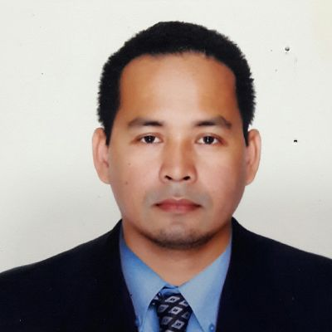
Llanasa, Nelson T.
Brgy, Lumbia Xavier Ecoville blk 15 lot 10
Cagayan de Oro city 9000, Philippines
Phone: 09518379401
Tel: 8827305
Email: nelsonllanasa@gmail.com

OBJECTIVE

To become an efficient employee, skilled with all the qualities needed for the task by being Responsible in everything I do. To be able to cope and share my knowledge, skills, experiences and
Talents to my future endeavors.

WORK EXPERIENCE
Lifeguard Supervisor & Tutor SRACO Lifeguard Project (ARAMCO) Kingdom of Saudi Arabia 03/2018- 03/2020
Responsibilities
- Rescue distress persons from beach/pool using techniques and equipment
- Compiles emergency as well as medical treatment report form
- Supervise the staff regarding duties and responsibilities evaluate the competency

Lifeguard Supervisor Al falak Lifeguard Project (ARAMCO) Kingdom of Saudi Arabia 05/2015- 05/2017
Responsibilities
- Supervise the staff regarding duties and responsibilities
- Rescue distress persons from beach/pool techniques and equipment
- ensuring the safety of customers, staff and other users of the facility

Lifeguard Splash island Al Othaim Investment Company Kingdom of Saudi Arabia 12/2012- 12/2014

EDUCATION

Southern de Oro Philippines College (SPC) 1996- 2000
Bachelor of Science in Customs Administration, Cagayan de Oro City 9000, Philippines
Misamis Oriental General Comprehensive High School (MOGCHS) 1993-1996
Secondary level, Cagayan de Oro City 9000, Philippines

SKILLS
- Customer Service, Leadership, Communication, Management, Interpersonal skills
REFERENCES

Engr. Pablo Paje Quality Assurance officer SRACO Lifeguard Project Phone: +966558479584

