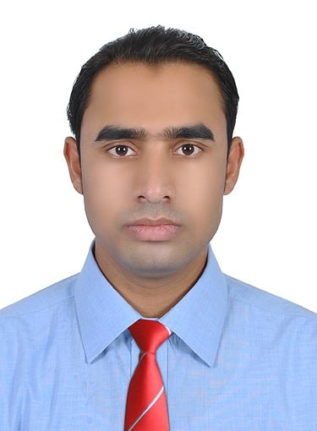
RAJIB HOSSAIN
Address: Abu Dhabi.
Mobile: +971-0504751077
E-mail: ahmed1991rajibhossain@gmail.com
OBJECTIVE:
To develop my career as a Guest Service Agent as I enjoy helping to ensure the smooth and conflict free functioning of customer facing operational areas of a business.
SALES PROMOTER & CUSTOMER ADVSIER  DANUBE HOME – Al Ain. | 2021 - PRESENT

- Promoter and Advice customers for purchase big amount of flower order.
- Advice and helping customers about flower order date and material fixing method.
- Maintain full Garden lobby (price Tagging, Arranging new material, Send and Answering e-mail about customers complain).
- Promoting and advising customers about all store items (Gazebo, Outdoor Sofa, Grass Carpet, Cash and Carry, Barbeque, Camping, Solar light, Kids play)etc.
- Visiting Customer sites for correct measurement (Grass carpet and Gazebo, Outdoor sofa

CUSTOMER SERVICE ATTENDANT.  FUNS SCAPES, REMALL MALL, AL AIN | 2018-2021

- Advising and assisting guests to purchase tickets for attractions
- To suggest new ideas to fulfill monthly revenue targets.
- Advice and assist customers about Play Area and Jumping lobby.
- Refill all the video games ticket dispenser and helping customer for technical support for video games.

CUSTOMER SERVICE AGENT.  ACTIONHAAA, SOUQ EXTRA MALL. AL AIN. | 2014 -2017

- Work in Redemption Counter and Art Gallery.
- Advising and assisting guests to purchase tickets for attractions
- Assisting customers to safely & correctly use attractions.
- Advise customers on how to play video game.

CUSTOMER DESK AGENT  LIFE TOY’S,KHALIDIYA MALL, ABU DHABI. | 2012-2013

- Fully responsible for the Redemption Counter.
- Completing monthly inventory of stock.
- Create new promotions to try and attract more customers.
- Communicate and lasting customers complain about Redemption Counter.
- Solving customers complain as much as possible.

PC TECHNOLOGY AGENT.  (COMPUTER TRAINING CENTER), BANGLADESH. | 2010-2011

- Work as a Trainer and Teacher (Ms. Word and Power Point)
- Manage over fifty students daily class routine.
- Monitored and guide all students.
EDUCATIONAL BACKGROUND:
SSC(SECONDARY SCHOOL CERTIFICATE)  HAZIR PARA HAIDIYA HIGH SCHOOL. | 2009
HSC(HIGHER SCHOOL CERTIFICATE)  KFILA UDDAIN DEGREE COLLEGE. | 2011

PROFESSIONAL DEVELOPMENT.
MS. WORD. MS POWER POINT. | PC TECHNOLOGY | 6 Month Courses.
GRAPHIC DESIGN. | PC TECHNOLOGY | 6 Month Courses.

- Have basic knowledge about Browsing and Social Media.
- Have ABC knowledge about Computer Hardware.
- Have basic knowledge about Video Editing and slide show.
KEY SKILLS:
- High standard of spoken languages (English, Arabic, Hindi).
- Thorough understanding of Middle East lifestyle, culture and U. A.E law.
- Extensive knowledge of how to handle all types of customers.
- General working knowledge of sign language.
- Excellent team worker.
- Confident to communicate with other nationality people.
REFERENCE:
MOHAMED OHID.
RECREATION SURERVISOR-KHALIDIYA PALACE RAHYAAN HOTEL. ABU DHABI –UAE
Mobile: +971-506188914. E-mail: moh.ohid@gmail.com

