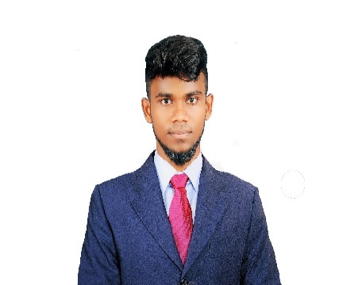
ismailkadar62@gmail.com

Linkedin.com/in/ Mohamed Abdul Kadar
MOHAMED ABDUL KADAR
ELECTRONICS ENGINEER
+917695836475
Pass port
R9933421
ABOUT ME
WORK EXPERIENCE
3.5 years
To obtain a challenging position with a leading organization to utilizing my qualification and talents.

AGE
24
Education

B.E, ECE Graduated, July 2019
National College of Engineering Marks 70%
India Division
Diploma, ECE Graduated, July 2015
Al- Ameen polytechnic college Marks 76%
India Division
Work Experience

Jan 2019 to Sep 2019
Electrical Technician ODSS Technical service (L.L.C)
Dubai
- BMS (Building Maintenance System) Maintained and Installation.
- Fire alarm system Maintained, installation.
- Firefighting Maintained.
- CBS & ELS (Central Battery System ) Installation and Maintained
- Installation / service of commercial alarm systems.
- Troubleshooting and repair of various systems.
- Cable installation, CCTV cameras installation, DVR configuration, access and support.
- Reported in for emergency repairs as needed when off duty.
- Documented and reported all service work performed.
- Repaired and replaced components including sensors and wiring.
- Came in for emergency system repairs on all shifts.
- Monitored electronic systems isolated problems and completed all needed repairs.
July 2015– March 2018
Electrical Technician
syndicate Electricals
India
- Knowledgeable of power tools and most hand tools.
- Lead several specialized teams within the department as needed.
- Write technically about work performed and submit reports to the department head.
- Manage daily work orders logs schedules and various project documentation.
- Reinstated relays switch positions sensing devices and motors with the use of hand tools.
- Used voltage tester and replaced circuit breakers and panels.
- Read blueprints and drawing schematics to connect power supplies to machines and equipment with correct wires or cables.
- Replaced faulty printed circuit boards.
- Cable installation, Termination, Troubleshoot clear.

Computer Proficiency

- MS-office(certificate)
- Electrical maintained software (commixing & Testing)
- Electronics software (printed circuit board design)
Languages

- English
- Hindi
- Malayalam
- Tamil
Personal Interests

- Arabic

- ELV Technician
- Central battery system & Emergency lighting system
- Building maintain system
- Fire alarm system
- Firefighting system
Personal Details

Father’s Name: Mr. Ismail Marital Status: Single
Birthday: April 09 1997 Nationality: Indian
Gender: Male
Current Location: INDIA
Declaration
I, Mohamed Abdul Kadar, hereby declare that the information contained herein is true and correct to the best of my knowledge and belief.
Mohamed Abdul Kadar. I

