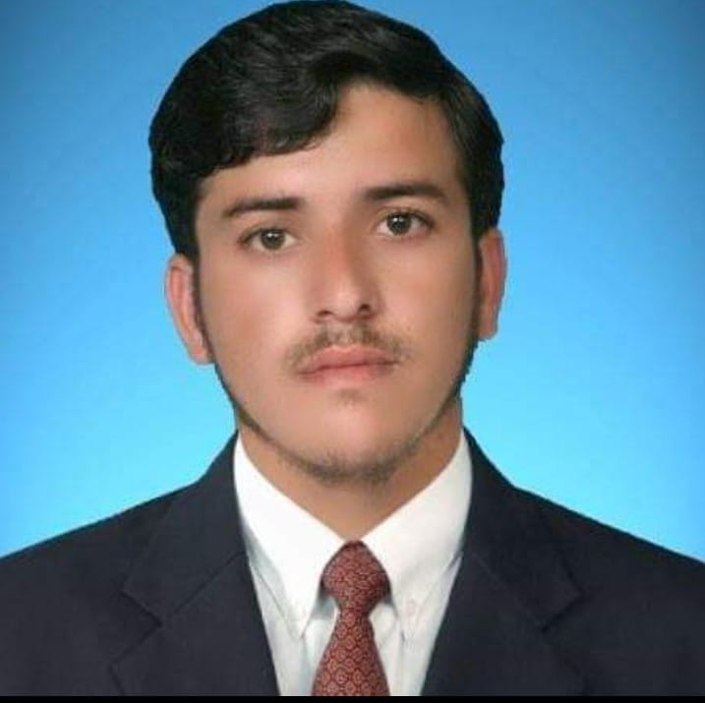
ABDUS SALAM

SAFETY OFFICER

Riyadh, Kingdom of Saudi Arabia

abdussalamkhanchan@gmail.com

00966583837058

Iqama Transferable

Summary

Result driven Safety Officer with 7 years of working experience in Construction industry. Consistent track record of successfully completed projects looking forward to devoting my services at best of my experience and capabilities.

Education

Bachelor of Science
(HAZARA UNIVERSITY PAKISTAN)

Professional certification

- 2 YEAR DIPLOMA IN PROFESSIONAL HEALTH AND SAFETY
- NEBOSH IGC1, IGC2 certified
- IOSH- Managing Safety
- OSHA 30 Hours construction
- Safety fire
- Safety chemical
- Safety first Aid

Objectives/Responsibility & Work Experience

Company Name: CHINA COMMUNICATION AND CONSTRUCTION
Position: SAFTEY OFFICER
Project Name: PAK-CHINA ECONOMIC CORREDORE
Duration: January 2015 to Feb 2020

Company Name: DESHAN CONSTRUCTION COMPANY RIYADH KSA
Position: SAFTEY OFFICER
Duration: FEB 2020 to MAR 2022

- Provided training to staff and workers about Safe System of Workers (SSoW), Permit to work procedures, safe material handling, safe use of tools, emergency response, safe use of heavy machinery and driving conduction of toolbox talks, use of fire extinguisher during fire, chemical handling provision of first aid and conducted safety drills.
- Conducted monthly HSE meetings to Coordinate and communicate with Contractor on special HSE issues of project.
- Prepared monthly safety inspection reports, accident/incident/near-miss investigation Reports for documentation and evaluation by analyzing the root cause to place effective corrective and preventive actions.
- Supervised the contractor safety control, safety auditing incident/accident investigation, Environmental aspect, impact risk assessment.
- Evaluated the hazards associated to construction machinery and provided solutions.
- Checked the health and safety conditions at project site and reported any hazardous condition needed immediate attention.
- Enforced the use of PPEs (Visible jackets, safety gloves, safety shoes, safety harness) at work. Sites of project.
- Conducted Safety inspection of construction machinery and vehicles (Excavators, Lifting Cranes Concrete Mixers, Batch Mixing Plants, and Dumper Trucks) periodically and maintained the records.
- Supervised the work sites of Bridges, retaining walls, tunnels, asphalt work and contactor camps for safe work procedures.

Additional

DIT (Diploma in Information Technology).

Computer Skills

- Word, Excel, PowerPoint
- Internet, outlook

PERSONAL PROFILE
- Father’s Name: Abdur Rahim
- Date of Birth: 18 Feb 1996
- Nationality: Pakistani
- Marital Status: Married
- Iqama No: 2511560241
References

References will be furnished on demand.

