CURRICULAM VITAE
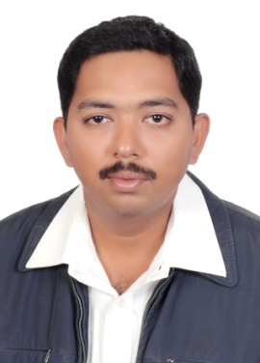

MOHAMED AFSAL KHAN.H
21 Rawda Street, Bayonia Phone :0509024689
AL KHOBAR , P.o.Box.30531 khalilrahman771@gmail.com Saudi Arabia . Present Address

Summary
8 years of professional employment experiences as an Information Technology professional. Strong technical knowledge in planning, installing and troubleshoot large and medium network infrastructures. Strong management, leadership, and supervising skills. Excellent project Works.
JOB FOR APPLY : IT CCTV Technician

WORKING EXPERIENCE.
8 Years Experience working as IT CCTV Technician in
Saad National Boys School. Al Rakka , Dammam, KSA ,
Since NOV 2013 to Until JUNE 2021

ACADEMIC PROFILE

Course : Diploma Computer Engineering
Major : Computer science
College : Regional Engineering College in Trichy (INDIA)
Percentage : 75%

EDUCATION BACKGROUND

- Passed SSLC, AL Ameen Matriculation & Hr. Secondary School, Kumbakonam , TN Board ,2000. INDIA.

Technical Skills:
Windows 7, Windows 10 ,

To be considered for the role of IT CCTV System Support you will have the following:
- 1st Level System Desktop support experience

- Backup Server Data Windows Server
- Skills for knowledge of Cisco and IP Networking Console

- CCTV Recording and NVR Recording POE Switch Configure IP Address DDNS
Network protocols (TCP/IP, NetBIOS, IPX, L2T)

PERSONAL INFORMATION

NAME : H.Mohamed Afsal khan
DATE OF BIRTH : 18.05.1982
NATIONALITY : Indian
GENDER : Male
MARITAL STATUS : Married
FATHER NAME : M.Halilur Rahman
LANGUAGES KNOWN : English, Hindi & Arabic

PASSPORT INFORMATION:

Passport No : Z2207362
Date of Issue : 02/09/2012
Date of Expiry : 01/09/2022
Place of issue : Riyadh
IQAMA Transferable : 2263473734

DECLARATION:

I here declare that the above furnished details are true to the best of my knowledge and
I would be the responsibility for the correctness of the above-mentioned particulars.

Place: Dammam
Date: ( H.Mohamed Afsalkhan)

