CURRICULAM VITAE
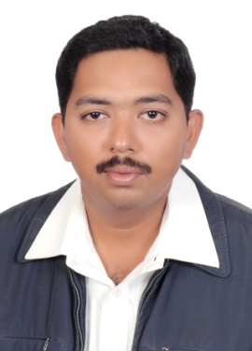MOHAMED AFSAL KHAN.H
21 Rawdah Street, Bayonia Phone :0509024689
khalilrahman771@gmail.com
Summary: I have been 8 years of experiences as an Information Technology professional. Strong technical knowledge in planning, installing and troubleshoot large and medium network infrastructures. Strong management, leadership, and supervising skills. Excellent project Works.
JOB FOR APPLY : IT Hardware Technician
Job Description:
IT Helpdesk Desktop Support (Level 1 &Level 2), Windows OS Troubleshoot and
Repair for Windows OS , Install, modify, and Repair computer Hardware and software.
IT Purchasing Job Computer Accessories Printer Toner and Etc.,

WORKING EXPERIENCE.
8 Years Experience working as IT HardwareTechnician in
Saad National Boys School. Al Rakka , Dammam, KSA ,
Since NOV 2013 to Until JUNE 2021

ACADEMIC PROFILE

Course : Diploma Computer Engineering
Major : Computer science
College : Regional Engineering College in Trichy (INDIA)
Percentage : 75%

EDUCATION BACKGROUND

- Passed SSLC, AL Ameen Matriculation & Hr. Secondary School, Kumbakonam , TN Board ,2000. INDIA.

Information Technology Skills:
Windows 7, Windows 10 , WINDOWS Server 2008,

Windows Server 2012 R2 & 2016 , and Win NT 4.0 workstation,

Apple MAC OS 10.5, 10.6 & Redhat Linux 6 & 7

To be considered for the role of IT Technical Support Engineer / 1st Level System Support Analyst, you will have the following:
- 1st Level System Desktop support experience

- Backup Server Data Windows Server
- Skills for knowledge of Cisco and IP Networking Console
- CCTV Recording and NVR Recording POE Switch Configure IP Address DDNS
- All Model Printer Laser jet Configuration Network Print server
Purchaser Job:
Purchase Product of Material Quantity, Maintenance tools, and equipment for their own company,Quotation order materials, Verifies purchase requisitions by comparing items Product. Requested to the Company and IT Product Computer Network Accessories and Printer Toner Etc.,

PERSONAL INFORMATION

NAME : H.Mohamed Afsal khan
DATE OF BIRTH : 18.05.1982
NATIONALITY : Indian
GENDER : Male
MARITAL STATUS : Married
FATHER NAME : M.Halilur Rahman
LANGUAGES KNOWN : English, Hindi & Arabic

PASSPORT INFORMATION:

Passport No : Z2207362
Date of Issue : 02/09/2012
Date of Expiry : 01/09/2022
Place of issue : Riyadh
IQAMA Transferable : 2263473734

DECLARATION:

I hereby declare that the above furnished details are true to the best of my knowledge and
I would be the responsibility for the correctness of the above-mentioned particulars.

Place: Dammam
Date: ( H.Mohamed Afsalkhan)

