ASAD KHAN
asad.khanjee@gmail.com
Contact # 0553219936
0590811592

(CIVIL ENGINEER)
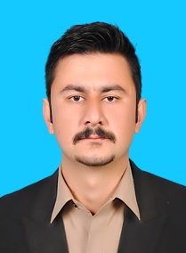
Nationality: Pakistani
Gender: Male
Immediate Mobilization
Iqama: Transferable
Valid Driving License (KSA)
Career Objective
Seeking a career that is challenging and interesting, and lets me work on the leading areas of technology, a job that gives me opportunities to learn, innovate and enhance my skills and strengths in conjunction with company goals and objectives.
Work & Experience

Technical Manager (QA/QC) April 2018 to Jan 2022
Employee: Akhunzaada Fazal Jameel & Co
Projects: Swat Expressway + SBBU University (PAK)

Material Engineer Nov 2015 to Feb 2018
Employee: Advance Construction Technology Services (ACTS)
Projects: KAIA airport + Jeddah Tower (KSA)

Site Engineer May 2015 to Nov 2015
Employee: Nile Foundation for Contracting (Nesma Water & Energy)
Projects: King Abdullah Economic City Infrastructure (KSA)

Junior Engineer June 2014 to March 2015
Employee: Save The Children’s (USAid)
Projects: Rehabilitation Project of Schools & Hospital due to Earthquake
Skills

Primavera P6 | AutoCAD | Construction Materials | Estimation
Communication skills | Works in teams as well individual | Site execution | Works remotely

Education (Academic)

B.Sc Civil Engineering 2010 to 2014
University of WAH (Pak)
- Internet Surfing
Languages Skills
- GIS

- English
- Arabic (basic)
- Urdu

