MOHAMMED AMINUL HAQUE

Nationality: Bangladeshi, Mob: 880-1671398810, Email: mahaque4@gmail.com
Dear Hiring Manager,

Applying for the position of Project Manager.

I am an M.Sc(Ag) in Horticulture Engineering from Bangladesh Agricultural University. Served more than 20 years under the Ministry of Agriculture, Bangladesh Government with full satisfaction of the authority. I was engaged always with multi disciplinary components in multi locations with, Horticultural fruits, vegetables and flowers, gardening, landscaping, colored plantations, training-pruning etc best practices for architectural design, teaching/training as well as Horticulture value chain activities holding strategic senior management positions.

Being a Horticultural Expert conducted observation with Organic and Hybrid Tomato for nutritional value assessment along with vicinity beautification, lawn,
turf etc. management with proper training to the mangers, field men, plot owners etc on the latest field suited practices e,g land selection & preparation, fertilizer & manure application, planting & caring, IPM, garden management, harvesting, processing, drying, storing etc, soil improvement & conservation practices for crop production and profit maximization.
Perhaps, it is not inconsistent to note that In my previous station achieved three times more coconut quality production in comparison to the previous year with best practices of garden suited fertilizer/manure application, mulching with water hyacinth, IPM practices along with field suited management technology. I do perform my duties even in weekends. Being a successful Horticulturist, I do believe that your honor would consider my prayer; if possible in other position.

Yours’ faithfully,
= (Mohammed Haque)=

Mohammed Aminul Haque 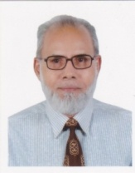 Nationality : Bangladeshi, Email: mahaque4@gmail.com, Mob:8801671398810

CAREER SUMMARY:

Innovative, oral & written communication skills, proven judgment and decision making tenacious professional with more than 20 years of sustainable fruit-vegetable gardening management experiences.

SUMMARY OF SKILLS:
@ Sustainable quality farming/gardening, plowing, planting, intercultural operations, training-pruning, house garden maintenance etc for fruit, vegetables etc.
@ Gardening with landscaping, architectural design, vicinity beautification, colored plantations, lawn-turf-water garden etc. management.
@ Preparation of annual action plan/progress reports based on climate change, adaptation and temperature tolerant farming/gardening plantations.
@ Kitchen wastes composting for soil health improvement for quality health nourishing and nutrient rich sustainable fruit-vegetables etc production
@ Managed integrated farming projects with mixed fruit-vegetables, dairy, poultry, fishery etc for natural quality foods as well as maximizing Agribusiness profit.
@ Conducted training of the target groups on the planting, gardening, soil health improvement, composting, irrigation, intercultural operations etc.
@ Encouraging application of living- non living mulches in the garden to conserve soil, soil moisture, soil water & nutrients etc.

EDUCATION AND TRAINING:
= M.Sc(Ag) in Horticulture from Bangladesh Agricultural University
= B.Sc Ag (Hons) in Horticulture-- -do-
= Surveyor( AMINSHIP-grade A) from Polestar Oxford Academy, Dhaka.
@ Project management
@ Crop Production Technology BRRI, Bangladesh.
@ Production techniques-wheat, potato, maize, tomato, fruits-vegetables.
@ Training for Trainers/CERDI, Bangladesh.
@ Teaching Techniques & Extension Methodology/CERDI, Bangladesh.
@ Teaching Methods & Techniques /CERDI, Bangladesh.
Areas of Training Received | Course Organized by | Periods
i) Standard English Course aimed to develop skills. | Bedford English Study Centre, U.K. | 10-06-86 to 8-8-86
ii) Storage of durable Agril. Products in the tropics. | TD & RI, Slough, U.K. | 15-8-86 to 23-12-86
iv) Extension Principles & Extension Management. | Chiangmai University,  Thailand. | 20-10-97 to13-12-97

W O R K H I S T O R Y:
=Volunteer  bdgardeningltd  =Field officer Comm. & Indus  ------------------------  = Director,  =Principal,  =Deputy Directors,  =DTO,s,  =SMS & others  Department, Agricultural  Extension,  Ministry, Agriculture, Bangladesh Govt | 07/2015 to till date  -------------  07/2007  to  06/2015  --------------  22-2-74  To  31/12/06 | @ Project preparation for Agribusiness, training on modern vegetable cultivation for maximizing return.  -----------------------------------------------  @ Quality vegetable production for export to EU and ME countries.  ---------------------------------------------------  @ Supervised ongoing development projects, plantations, farming, gardening and scrutinized farm records (labor & cultivation registers, overseer’s diary, calendar of work etc)  @ Made discussion with the stakeholders, policy- makers for sustainable business area development for maximizing yield and profit.  @ Facilitated the target groups with the income generating business related activities as well as disseminated sustainable Horticulture, Forest and Timber plantation technology appropriately.  @ Extended strategic vision, overall executive leadership, technical, financial as well as future program planning.  @ Managed and trained plantation labors on the soil conservation, mulching, gully erosion, jungle cleaning, terrace cultivation techniques, SALT, pest control in IPM, intercultural operations and plantation Agribusiness for maximizing profit and minimizing operational cost.

REFERENCES:
i)Dr Shahidul Islam, Team Leader, World Bank funded -Service provider
for the distribution of house hold silos.Cell- 01732608333, Email : s.islam_dae@yahoo.com

ii) MD AKBAR HOSAIN, Director, Banglar Alo Ltd.S/o Abdus Salam, Omega Engineering,
House 36, Road 06, Mirpur 10, Dhaka,Email makbarhosain@gmail.com, Mob 01730902840
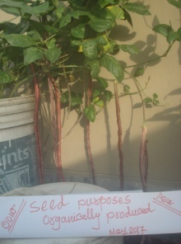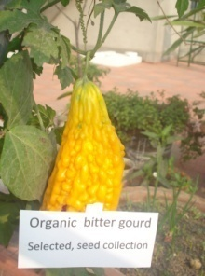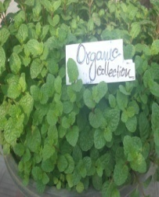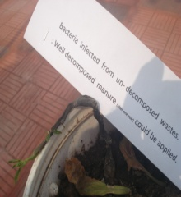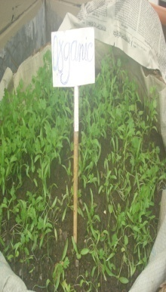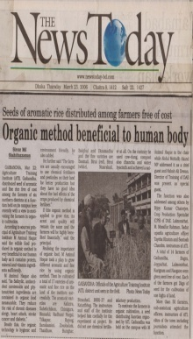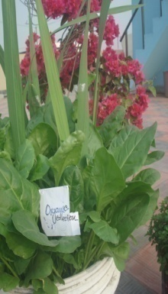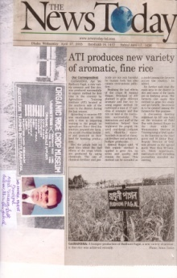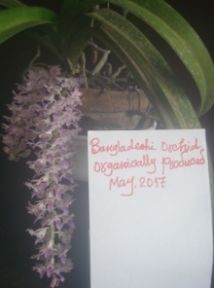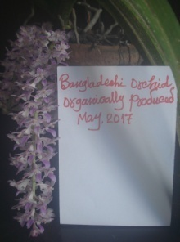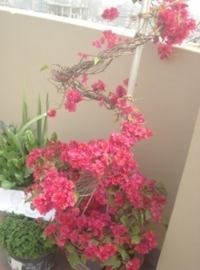
My Gardening in Picture.
LANGUAGES:
English- Fluent
Bengali - Native
Arabic- Basic/ learning
CERTIFICATION :
“I certify that all information stated in this resume is true and complete to the best of my knowledge. I do authorize the concerned authority to verify the information provided in this resume”.
(Mohammed Haque)

