MOHAMMAD MERAJ ALAM
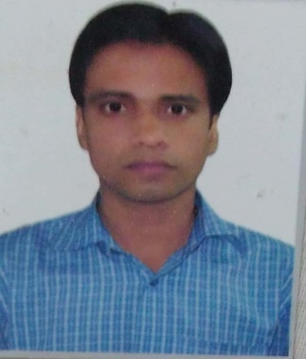
Address: - Dar Al Baida
Riyadh, Saudi Arabia,
Contact Number - +966-569174879
E-mail Id: - merajhasan84@gmail.com

OBJECTIVE:-

with the intention not merely to obtain a job but to serve for an organization having a professional set up venture to a position, which provides responsibilities and an opportunity to have my skills and knowledge effectively. It helps to achieve desired goals and to excel as a team player.

STRENGTH:-

To understand the responsibility and do according to the situation willingness to work hard and have a strong commitment toward quality work.

QUALIFICATION DETAILS:-

Bachelor degree in Pharmaceutical Sciences from Lovely Professional University Punjab (India) in 2013.

AREA OF INTEREST:-

Hospital Pharmacist, Clinical Pharmacist. Retail Pharmacist, Warehouse Pharmacist, Central Drug store Pharmacist

COMPUTER SKILLS:-
Diploma in computer applications (MS Office, MS Word, Power Point, Excel), and Internet.
PERSONAL SKILLS:-
- Strong analytical and people management skills
- Excellent Verbal & personal communication skills
- Accuracy and attention to details
- Passion for constant improvement
- Self motivated, focused and dedicated
- Ability to take sound decision

Registration and Accreditation :-
- Registered with Saudi Commission for Health Specialties, Kingdom of Saudi Arabia.
- Registered with Delhi Pharmacy Council India.

Work Experience:-
Sr. No | Name of the Employer | From | To | Designation | Year of Working
1 | AMI SAUDIA ARABIA LTD | SEPT 2015 | Till Now | Pharmacy Technician | Working
2 | Bansal Hospital New Delhi India | June 2013 | June 2015 | Hospital Pharmacist | 2 Years

JOB RESPONSIBILTY:-
- Checking prescriptions to ensure that there are no errors and that they are appropriate and safe for the individual patient.

- Providing advice on the dosage of medicines and the most appropriate form of medication, for example, tablet, injection, ointment or inhaler.

- Ensuring medicines are stored appropriately and securely

- Answering questions about medicines from within the hospital, other hospitals and the general public.
- writing guidelines for drug use within the hospital and implementing hospital regulations; Providing information on expenditure on drugs.

- Maintains safe and clean working environment by complying with procedures, rules, and regulations.
- Hospital. Monitors inpatient and outpatient drug therapies when appropriate and works with the appropriate medical staff to find alternatives when needed. Also facilitates medication reconciliation process and works closely within a multidisciplinary team to ensure the best care is provided.

- Work closely with medical staff to seek alternatives with drug therapies, and the appropriate
Multidisciplinary teams to ensure the best care possible.

PASSPORT DETAILS:-

Passport No. : U0148502
Date of Issue : 10-11-2020
Date of Expiry : 09-11-2030
Place of Issue : Riyadh (Saudia Arabia)

PERSONAL DETAILS:-

Date of Birth : 15-Feb-1984
Father Name : MD. Hassan Mujtaba

Marital Status : Married
Expected Salary : Negotiable

Nationality : Indian
Country of residence : Riyadh (Saudia Arabia)
Language Known : English, Urdu, Arabic, Hindi
Contact No. : +966-569174879
Skype ID : merajhasan84@gmail.com or +966569174879

Date: 22/04/2021
Place: Riyadh (Saudi Arabia) (MOHD MERAJ ALAM)

