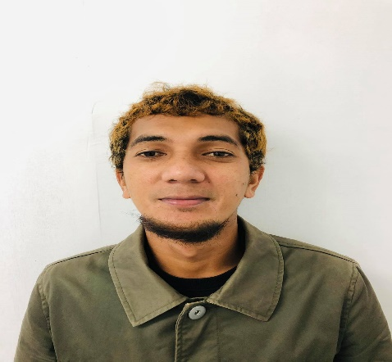
SIDRI O. LADJAMATLI
Wee GuiaoDrive,Sta.Catalina Zamboanga city
09274240511
Jham2001517@yahoo.com

POSITION DESIRED: CIVIL ENGINEER

CAREER OBJECTIVE:

- Excellent ability to complete task on time, able to work with confidence,take initiative, willing to learn, and can work independently or in team.
- Ability to work unsupervised, able to motivate and lead others in a team environment.
- Patient, reliable and flexible to different situation and remains effective in multitasking.
- Adapt new concept quickly while working under pressure.

WORK EXPIRIENCE

Duration : November 22, 2015 – Present
Company Name : Metro Stonerich Corp.
Company Address : #03 Scout Rallos, Brgy. Laging Handa, Quezon City
Designation : Site Engineer (Structural & Architectural)

RESPONSIBILITIES:

- Monitoring materials delivered on site.
- Perform other job that may be assigned from time to time.
- Prepares weekly accomplishment status.
- Assist superintendents and subcontractors and ensure compliance to all project coordinate survey team and prepare works schedule as per plan and drawing for project.
- Cary out inspection and checking all quality related procedures in the site and ensured activity at the site as per approved method statement and inspection test plan.
- Resolving the technical problem with the subcontractors in the construction site regarding the site issues.
- Schedule.
- Estimate and order materials to be used in the balance of work in the project site.

PROJECT ACCOMPLISHED:

- SM Mindpro at Zamboanga city on December 8, 2020

- Cabatangan Evacuation center at Cabatangan Zamboanga city on May 12, 2020

- Zamboanga Ace Medical Center At Tetuan Zamboanga City on May 21, 2019 -Present (ongoing)

- Government Housing Project ( 5 units 6 Storyes Building ) at New Clark City, Capas, Tarlac on January 31, 2019 – May 6,2019

- Robinson Place Valencia at Hagkol, Brgy. Bagongtass Valencia City, bukidnon on July 21, 2017 – December 12, 2018

- Robinson Place Iligan & Go Hotel at Brgy. Tubod Iligan City on November 22, 2015 – July 26, 2017

TECHNICAL AND SPECIAL SKILLS:
- Operating Microsoft office program (Word, PowerPoint and Excel).
- Excellent communication and writing skills
- Strong and analytical and problem solving skills
- Ability to work independently and under pressure
- Ability to work well in team environment and able to express accuracy attention to detail
- Responsible to other duties assigned
- Friendly

CHARACTERS REFERENCE:

Name : ARCH. MARCELO L.TABAMO
Position : AREA MANAGER
Company : METRO STONERICH CORP.
Contact Number : 09178495650

Name : ARCH. LUIS G. SALAMAT
Position : PROJECT MANAGER
Company : METRO STONERICH CORP.
Contact Number : 09171239791
Name : ENGR. IDRIS AMINULLA
Position : PROJECT MANAGER
Company : METRO STONERICH CORP.
Contact Number : 09153229664

Name : ENGR. GARIE DELA CRUZ
Position : PROJECT MANAGER
Company : METRO STONERICH CORP.
Contact Number : 09174794619

EDUCATIONAL ATTAINMENT:

PRIMARY : Bubuan Central elementary School 1997 – 2002

SECONDARY : Basilan National high School 2002 – 2006

COLLEGE : Universidad De Zamboanga

COURSE : B.S. CIVIL ENGINEERING 2002 – 2013

PERSONAL PROFILE:

Age : 32
Sex : Male
Status : Married
Date of birth : February 6, 1989
Height : 5’6”
Nationality : Filipino
Religion : Islam

I do hereby certify that the above information is true and correct to the best of my knowledge and ability.

SIDRI O. LADJAMATI
APPLICANT

`

