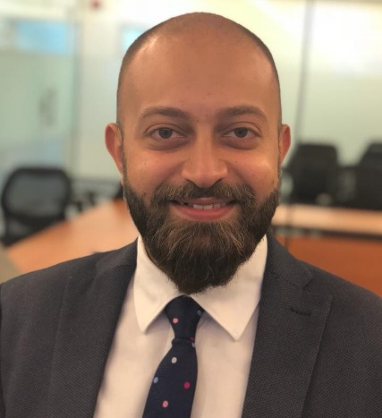
Ahmed Kamal Ashry
Transferable Iqama
KSA-Address: 5 El-joof Street, Sulimanya District, Riyadh.
Egypt-Address: 10 block 5 Elnabawy Elmohandes Street, Elsefarat District, Nasrcity, Cairo.
E-Mail: Dr.ahmedelashry@live.com
Mobile: +966569941076
Mobile: +201140708244
Military status: Exemption
Driving licenses: Valid till 2023
Date of birth: 23rd May 1988
Status: Married
OBJECTIVE
I’m seeking a challenging position in a reputable company where my interpersonal, communication, technical and presentation skills can be applied and further developed and where advancements and earnings are based upon performance and achievements.

Summary
I have more than 10 years experience in cardiovascular line as I worked on Diabetes products (Trajenta), Antihypertensive products (Micardis&Sevikar&Sevikar HCT) and Anticoagulants products (Clexane& Pradaxa).

EDUCATION

Misr International University Cairo, Egypt

Bachelor degree in Pharmaceutical Sciences, Faculty of Pharmacy

Cumulative GPA: 2.09

Graduated on July 2011

Tabary Roxy School Cairo, Egypt

Graduated Class 2005

Cumulative GPA: 92%

WORK EXPERIENCE
SAJA Pharmaceutical (March 2017 – March 2021) Riyadh, Saudi Arabia
- Key account manager
- Senior Product Specialist
- Responsible for (Sevikar & Sevikar HCT) CVS line, 1st January 2018.
- Responsible for ( Omnic & Vesicare ) – Uro-Gyne Line (Urology & Gynecology)
- Responsible for ( Dr.Suliman Alhabib Hospital All Branches, Alhamdi Hospital, SMC Hospital, Dallah Hospital, Al-Hayat Al-Watany Hospital & Sanad Hospital )
- Coverage Doctors: Cardiology, Endocrinology and Internal Medicine.
AmdiPharm Mercury (October 2015 – February 2017) Riyadh, Saudi Arabia
- Key account manager
- Responsible for ( Fucithalmic & Neomercazole )
- Responsible for Total Riyadh & Qasium region ( MOH, Institutions, Private)
- Coverage Doctors: Ophthalmology and Pediatrics.
Boehringer Ingelheim (October 2013 – October 2015) Riyadh, Saudi Arabia
CVS Line
- Medical Representative
- Responsible for ( MICARDIS & PRADAXA )
- Participated in the launch of the Diabetes Portfolio (TRAJENTA)
- Responsible for ( Al-Hamadi Hospital, SMC Hospital, Saudi Germany Hospital, Dr.Suliman Al-Habib Hospital “Olaya Branch” & Al-Hayat Al-Watany Hospital )
- Coverage Doctors: Haematology, Oncology, Cardiology, Internal Medicine, Pulmonology, Neurology, Orthopaedic and Endocrinology.

Milestone
- Best achiever Riyadh region 2014.( Total Portfolio )
- Enlisting PRADAXA 150mg in all main accounts.
- Coding for SIFROL in Hamadi Hospital.
- Best achiever PRADAXA all over the Kingdom 2014.
Sanofi Egypt (February 2012 – August 2013) Cairo, Egypt
Hospital Line
- Medical Representative (Clexane, Tavanic, Targocid, Xatral XL, Bi-Profenid).
- Responsible for Old Kasr Al-Aini, Internal Medicine ICU hospital & pediatric hospital (Cairo University Hospitals), Al-moa'lemen Hospital, Sadr Al-Abassia Hospital, and Abassia region.
- Participated in relaunch of Xatral XL.
- Coverage Doctors: Cardiology, Chest, Internal Medicine, Surgery, Urology, Orthopedic.

Milestone
- Sales Achievement: Growth over 150 %.
- 1st introduction of Targocid in some units as ICU unit.
- Market share of clexane is over 90% in kasr alaini.
- Strong & sustained relationships with KOL.

Al-Zoghbi Pharmacy (July 2011 - January 2012) Cairo, Egypt

Pharmacist
- Worked as a community pharmacist.
- Patient counseling.
EXTRACURRICULAR EXPERIENCE

MIU Stock Market Stimulation (February 2010 –March 2010)
- Delegate

MIU Model United Nations (July 2008 –May 2009)
- The Founder of the MIU-MUN
- First Secretary-General of the MIU-MUN

MIU Students in Freed Enterprise (2006 - 2009)
- Participant

Scopes 2007 (The 2nd student conference on pharmaceutical studies at Ain Shams University)
- Participant
Summer Training

AL-Zoghbi Pharmacy (Summer 2010)
- Summer Training as Pharmacist.

AstraZeneca Egypt (July 6th-september 5th 2010)
- Summer Training as Medical Representative.

Rabab Habib Pharmacy (Summer 2009)
- Summer training as pharmacist.

Maher Nada Pharmacy (Summer 2008)
- Summer training as pharmacist.

Pfizer Egypt (June 28th-July 10th 2008)
- Summer Training as Medical Representative.

Extra Courses

Key Account Management at Boehringer Ingelheim KSA (2015)

Presentation and Negotiation Skills at Boehringer Ingelheim KSA (2014)

Advanced Selling Skills at Boehringer Ingelheim KSA (2014)

Key Account Management at SANOFI Egypt (2013)

Project Manager Preparation at American University in Cairo (2013)

Principles of marketing course at Misr International University (2009)

Promotion and management courses at Misr International University (2008)

Skills

Computer Skills:
- Proficient user of Microsoft Office.
- Proficient user of Internet.

Languages:
- Arabic: mother tongue.
- English: very good.
- French: fair

Reference contacts

- Hazem Mansour “Regional Sales Manager" at Boehringer Ingelheim
Mobile : +966530117815
- Mohamed Gamal “Regional Sales Manager” at Boehringer Ingelheim
Mobile : +966545155461

References and samples of work are available upon request

