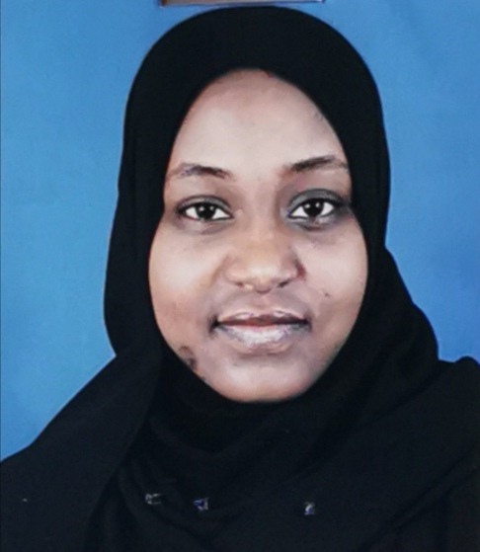
CURRICULUM VITAE (CV)
SALI HATIM MOHD OSMAN AHMED

OBJECTIVE
To secure a position with an organization offering long term growth, conductive to professional growth and achievement.
PERSONAL INFORMATION
Nationality: Sudanese
Date of Birth: 02-01-1986
Place of Birth: Khartoum- Sudan
Marital status: Married
Passport N. : P08100633
Visa type.: . Visit visa
Address : Riyadh - KSA
Contacts: TEL. +966557718165 - +966509213339
E-mail: saleehatim@ymail.com

EDUCATION STAGES
Higher secondary school: Sudanese secondary school – DOHA.
University: University Of Khartoum - Faculty of Pharmacy.
Degree: Bachelor of Pharmacy (Honours) 2008.
Master of Clinical Pharmacy : University of Khartoum (2018 - now)
EXPERIENCE
- Full registration in Medical Council - SUDAN since Aug’09.
- Practicing license as Pharmacist from Supreme Council of Health– Qatar, Dec’2012.
- Worked at Elbourda Pharmacy (2009-2011) and Zuhair Modern Pharmacy (2009-2010).
- Finished military service in ElamalHospital , March 2010 to March 2011.
- Worked atAlkawther Pharmacy (Doha ,Qatar)dec’2012-Aug'2013.
- Worked in Dr Fahad Dermatology Centre (Doha ,Qatar)Sep’2013-Feb’2014.
- Worked in Dr KaldariSurgi-Art Centre (Doha-Qatar)March’2014 – January’2015.
- Studied master of clinical pharmacy at university of khartoum - pharmacy collage (Feb ‘2018 -waiting for final result)
Skills
- Inventory management, patient education, pharmaceutical assessment, insurance and communication skills (very good).
- Microsoft Office skills (good) and SPSS analysis skills (beginner).
- Workload management, negotiation and team work skills (very good).
LANGUAGE
-Arabic. - English.

