Key Skill(s)
Driver.

SUMMERY
- Profile / Gender: | Mail / 55 ys, old, non-smoking and non-alcoholic.
- Nationality: | Yemeni, Family resident in Yemen.
- Current Location: | Riyadh / Saudi Arabia.
- General Position: | Driver 30 yeas of driving in Yemen and Saudi Arabia.
- Preferred Locations: | Any place worldwide.
- Requirements : | Accommodation and other.
- Driving License : | Saudi Arabia Exp Date 27/09/2018.
- Employment /status : | Employee / Full Time/ able up to 100% Travel (international passport )
 | - Please chat with me on WhatsApp 00966558830969 or call me through Duo, IMO or an international call.

Am a Driver for about 30 years in Saudi Arabia and Yemen.
- Science, Sana'a Institution / Sana’a, Yemen (1998).
Microsoft Office (Excel, Word, PowerPoint and General Accounting.
- Mohamed Ali Othman High School/ Yemen (1982) Maths, Physics, Chemistry, English Language and Religion.

LANGUAGES & SKILL
- Arabic (Native).
- English ( Reasonably fluent )

Job Skills.
- (Solid Office tools Package ) SAP software, Microsoft Office -Excel, Word, PowerPoint, outlook and General Account.

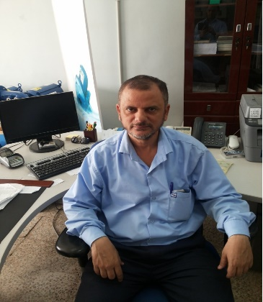 | Dear Sir/Madam  Please find attached a copy of my CV for your consideration. I believe that the skills I have in the driving skill of 20 years are good for any organisation.  I am an excellent candidate for this vocation as it is matching my skill and experience.  Ready to work in any place inside or outside the country (Region).  Many thanks, looking forward to hearing from you soon.  Yours faithfully,  Gehad Alahdal  Mobile: 00966558830969, Twitter: @gehad558830, Email ID: gehadalahdal@yahoo.com  Riyadh, Saudi Arabia.

