Resume
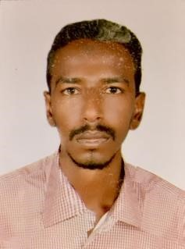
Ahmed aboalgasim siddige Ibrahim – civil engineer
Khartoum-sudan|aahgasim12@gmail.com|00 971 52 475 8511

Career objective
I am an enthusiastic,self-motivated, reliable, responsible, and hardworking, adaptable to all challenging situations, using my own initiative and work team cooperation. I am a certified civil engineer with advanced career tools certified knowledge, in addition to the various
work experience.

Work experience
Libra contracting june 2018- current
Projects manager
Site management ✓
Equipment management ✓
On-site engineering management ✓
Managing the workers on the site ✓
Design maps ✓
Building planning ✓
Maintenance and restoration ✓
Quantity calculation ✓

Al Marhoon technical engineering 2017
Establishing the company and working as a general manager ✓ International cranes meeting company april 2014-may 2017
Dammam-Saudi Arabia

Study of construction ✓
Finishing plans ✓
Project management and worker ✓
Crane installation ✓

Kardash company may 2013-may 2014

Quantity surveying ✓
Mapping ✓
Site engineer ✓

Move butter company july 2010- june 2013

Site engineer ✓
Material warehouse management ✓

Al-sir mirghani khaled company april 2011-september 2011

Follow up of building works and construction ✓

Education
Sudan university of science and technology
Khartoum-sudan
Diploma civil engineering graduate July 2010

Technical courses

Plan swift quantity calculation program course and calculate ✓ quantity manol
Autocad 2D-3D course from the future builders training ✓ center with a very good grade
Ministry of water and infrastructure (building drains, ✓ repairing drains and installing bridge)
Primavera p6 project management

Technical skills

Proficiency in autocad ✓
Proficiency in the use of powerpoint ✓
Use the office and word ✓
Proficiency in the use computer ✓
Easily calculate quantities ✓
Crane installation ✓

Personal skills
Customer service
Organization ✓
Setting goals ✓
Creativity ✓
Strong work ethic ✓
Problem solving ✓
Flexibility ✓
Time management ✓
Planning ✓
Team work ✓
Marketing and sales
Restaurant management
Data Entry

Language
Arabic_ english

