Z  A |  | Zaher  - Al-Ibrahim
 |  | PROFESSIONAL TITLE
 | (966) 56-255-3055 |  |  | ABOUT ME
 | Zaheralibrahim21@gmail.com
 | Safwa/Qatif/Eastern Province |  |  | I’m always looking to improve and learn new things, I love working and reaching goals and beyond. | I’m willing to work under pressure, reaching full satisfaction at work is always part of my goal, the benefit of the company is always going to be my first priority.
Skills  Social Skills  7 / 10  English Language  8 / 10  Problem solving  9 / 10  Learning and adapting skills  10 / 10  9/10  Education  Associate Degree/ Executive Secretary  Institute of Public Administration  Graduated on 19/01/2017  Course / NEBOSH  The national Examination board in occupational safety and health  Award on 22 November 2019  Course / occupational safety and health  TAFE Institute  9 months – graduated on 28/05/1440 |  |  |  | Experience  Safety Officer  C.A.T international/ Khobar / 02/2022-End  As a safety officer I’m in charge of the safety and well-being of workers and the condition of the workplace with all loyalty and honesty  - Ensuring the safety of workers, civilians and the workplace.  - Inspecting the equipment and observing and reporting any problems.  - Weekly inspection and color code management and checklist.  - Organizing and sorting the Reports/files and maintaining a safe and healthy work environment.  - Stop working depending on the situation or how dangerous the work might get as well as how fast the wind speed is.

Associate Degree
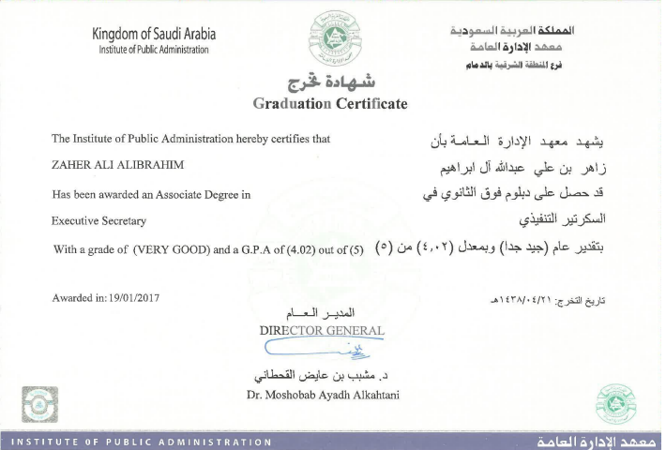
TAFE INSTITUTE
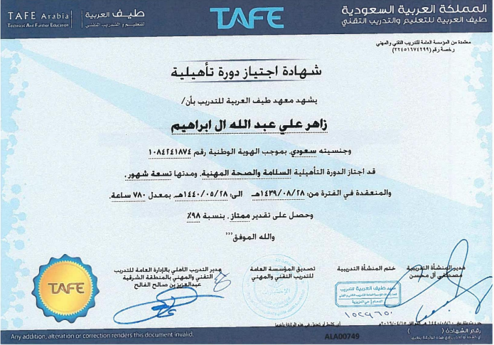
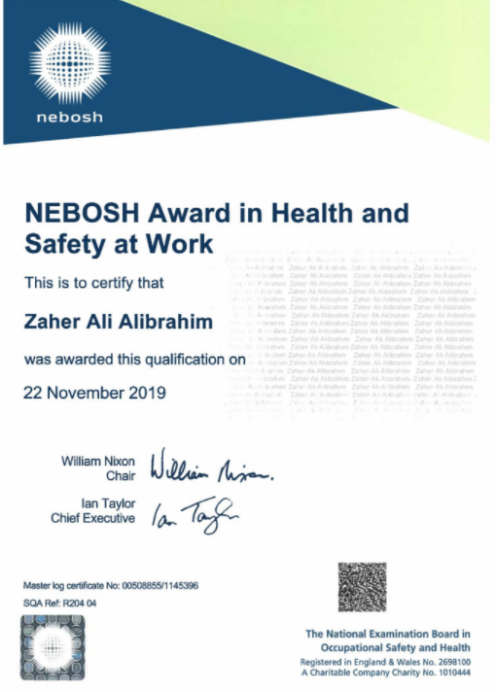
NEBOSH Award

