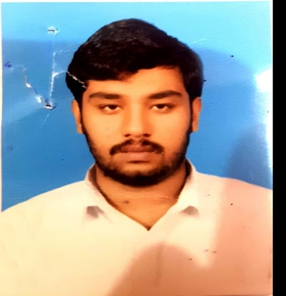
Bilal Rafiq Awan
Contact 03083734911
ADDRESS Khushal Colony house No 319 Street No 03 Khanewal Road Multan. .
bilalrafiqawan@gmail.com
Objective

I want to do more work in a learning environment to actualize my capabilities and utilize my abilities, to seek the organizational and personal growth on the long term basis.

Father’s Name | Muhammad Rafiq Awan
Date of Birth | 23-July-1996
Marital status | Single
Gender | Male
NIC NO | 36302-4515175-5
Passport No | CE1601751
Nationality | Pakistani
Religion | Islam

Technical skills:

- Monitored all health and safety activities and ensured appropriate implementation.
- Ensured compliance to all determined standards for all HSE programs.
- Inspected all contract equipment and ensured compliance to all HSE regulations.
- Administered all emergency response activities and recommended improvements as per requirement.
- Inspected job site in case of hazardous work activities and performed safety analysis on it.
- Analyzed all site accidents and recommended correction when required.
- Preventive Maintenance, Turnaround Maintenance

- MS Office (MS Word, MS Excel, MS Power Point).
- Internet Surfing.

- Hardworking & Quick Learner Excellent Oral & Written Communication

Work Experience :

Permit receiver at Pepsi.co Multan (2016-2018)

Responsibilities:
- Initiating and completing all applicable section of the permit to work.
- Supervising the work prescribe in the permit to work to ensure it is conducted in the most efficient manner.
- Notifying the issuer of work progress and completion, and ensuring that the site is returned to a safe and operational state .
- Taking adequate care to preserve the permit in good condition .
- Providing and arranging all necessary resources related with performing the work, including standby- man for confined space entry.
- . Revalidation of work permit is required.

(Safety Officer)
Pak Arab Fertilizer Pvt Limited Multan Responsibilities:
- Carry out incident investigation and reporting.
- Strictly maintained high standard of House Keeping & Waste management as per company policy.
- Facilitate inspections, audits and Toolbox Talks, on near miss and High Risk activities.
- Weekly inspection of all the fire extinguisher and kept in the secure position and also maintain
- Taking corrective action against Safety Voilation

Education:
Bachelor In Public Administration (2021)
CERTIFICATION:
- IOSH + OSHA.
- Nebosh

