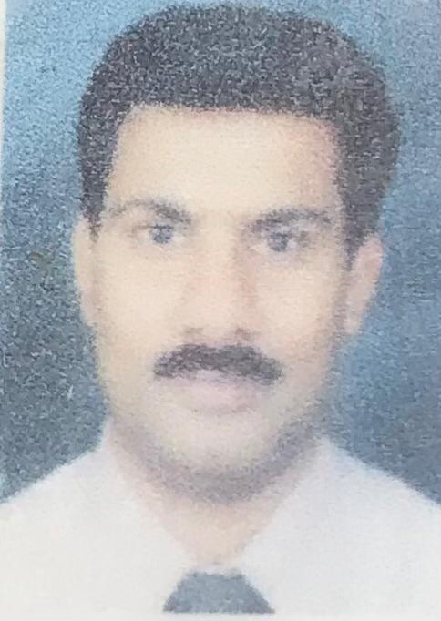

Regi Jacob

Chief Accountant
jacob.regi@gmail.com
+966537464044

SKILLS
Standards of accounting
Knowledge of regulatory standards
Financial Statements
Software proficiency
IFRS & GAAP proficiency
Adv. bookkeeping skills
Financial modeling
Auditing
Data Analysis
Prioritizing
Effective communication
Critical thinking

DECLARATION
I hereby declare that all the information given above are correct and true to the best of my knowledge.

PROFILE
Experienced Chief Accountant successful at cultivating effective working relationships at all levels while driving improvements to budget administration, expense tracking and forecasting of future financial needs. Proven track record of performing work in ethical manner while maintaining integrity of all financial data.

PROFESSIONAL EXPERIENCE

Chief Accountant, Novel Arabia Middle East Ltd

(Erstwhile Natco Al-Rushaid Middle East Ltd)

Al-Jubail, KSA (April 2009 – July 2022)
- Perform financial analysis and reporting to management.
- Dealing with all the management and financial transactions.
- Responsible for a team of accountants.
- Perform month-end accounting activities such as reconciliations and journal entries.
- Coordinate with finance team to complete assigned accounting tasks within deadlines.
- Analyze financial discrepancies and recommend effective resolutions.
- Monitor expenditures, analyze revenues and determine budget variances and report the same to management.
- Respond to accounting inquiries from management in a timely fashion.
- Provide guidance to other Accountants when needed.
- Assisting departments with annual budgets and reviews, internal control.
- Dealing with all the management and financial transactions
- Handling month-end and year-end financials independently.
- Evaluated and improved accuracy and completeness of periodical financial records to boost regulatory compliance.
- Partnering with auditors to prepare yearly audits and ensure compliance with governmental tax guidelines.
- Tracked and documented all expenses.
- Handling year-end closing processes of financials with controllers and external auditors.
- Reconciled balance sheets and streamlined best practices for balance sheet processes.
- Collaborated with bank representatives to negotiate capital requirements.
- Methodically review documents and accounts for discrepancies and resolved variances

Payroll Administrator, Parker Al-Rushaid Drilling Co Ltd.

Al-Khobar, KSA (Feb 2007 – Mar 2009)
- Managed payroll processing for 650 employees
- Calculated salaries, rate changes, retroactive adjustments, overtime, bonus, vacation, termination and garnishments using Company's self-developed Data Base Software
- Led payroll production for 6 locations
- Maintained employee confidence and protected payroll operations by keeping all information confidential.

Senior Accountant, Al-Rajhi International Clinic

Al-Khobar, KSA (Aug 2002 – Jan 2007)
- Develops, implements and maintains general accounting systems and controls; supervises and participates in the review and analysis of accounting records
- Assists in the preparation of detailed financial plans for management by analyzing and evaluating statistical and financial data and preparing budgets, projected patient levels, proposed staffing requirements and projected operating costs
- Defines the accounting requirements for management for incorporation into the patient accounting system, fiscal and statistical information system and other medical center accounting systems
- Analyzes data and proposes methods for tracking and reporting financial information to various external agencies
- Prepares financial reports including cost reimbursement plans for medical insurance providers;
- and reviews the work of subordinate accountants and clerical personnel; trains and
- evaluates personnel
- Prepares monthly financial statements including Balance Sheet, Statement of Revenue and Expenses, and Statement of Cash Flow
- Acts as Hospital liaison for medical insurance companies.

EDUCATION

M. Com, Advanced accounting and costing,

Kerala University, Trivandrum, Kerala, India,

March 1990

B.com, Calicut University, Calicut, Kerala India, April 1987

P.G Diploma, Computer Application,

April 1992

Currently undergoing a course on Diploma in International Financial Reporting of ACCA

PERSONAL INFORMATION
Birth Date: | 28 May 1966
Gender: | Male
Nationality: | India
Visa Status: | Residency Visa (Transferable)
Residence Location: | Jubail, Saudi Arabia
Marital Status: | Married
Number of Dependents: | 2
Driving License: | Saudi Arabia

Languages:
English
Hindi
Arabic
Malayalam

