CURRICULUM VITAE

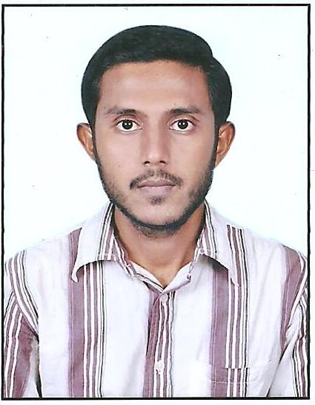

Abdul Hadi

Hyderabad, India.

Mobile: +91-7207220350

Email: : hadi.abdul0489@gmail.com

Looking forward for an organization that will appreciate my contributions and reward my efforts, having a team of professionals and quality environment where my knowledge can be shared and enriched.

Seeking a position as a Draughtsman in a very challenging environment having around 12 Years of experience in Shop drawings and Interior designing.

Organizational Experience

Organization | : | Eye View Designers
Designation | : | AutoCAD Draughtsman.
Duration | : | May 2009 to October 2014.
Location | : | Hyderabad, India.

Key Deliverables

- Site development plans from architectural blueprints.
- Drafted topographic maps using Auto CAD.
- Created both 2D and 3D design layouts by working with senior engineers and site engineers
- Prepared residential drawings using Microstation.
- Assisted engineers in daily work and design projects.
- Performed electrical planning and installation for residential villas and commercial establishments on MEP

Organization: Saudi Bin Laden Group (SACODECO) (Saudi Company for Development of Construction & Trading LTD.) AutoCAD Draughtsman, SBG.
Designation | : | AutoCAD Draughtsman.
Duration | : | Dec 2014 to Sep 2020.
Location : Jeddah , SAUDI ARABIA

Key Deliverables

- Worked as a draughtsman for almost 7 years in SBG Sacodeco
- Having experience in shop drawings
- Interior Designing

Academic Qualification:

- COMPLETED B.COM first year Hyderabad, India.
- INTERMEDIATE (MPC) from Mumtaz Jr. college 2008
- SSC Board of Secondary Examination from Hyderabad Mission High School 2006

Certifications:

- Certificate Course in Architectural CAD (Auto-CAD) from Graffiti Engg Solutions (2009)
- Certificate Course in Micro Station from Graffiti Engg Solutions (2010)
- MEP from NGCC Institute (2011)

Technical Training Courses:

- Diploma Certification Course

- Diploma in Computer Application (DCA) from Taiba Technical Academy (2009)
- Post Graduate Diploma in Computer Application (PGDCA) from GNIT (2009)

Computer Proficiency:

- Knowledge of Basic Computer automation tools (Word, Excel, and Power Point)
- AutoCAD (2D & 3D)
- Micro station

Skills
- Ability to learn things faster.
- Strong Determination.
- Positive Attitude.
- Hardworking, Sincerity towards work
- Leadership quality
- Punctual to work

Personal Profile:-

Name : Abdul Hadi

Father’s Name : Late S. Abdul Bari

Marital Status : Married

D.O.B : 26/04/1989

Nationality : INDIAN

Language proficiency : English, Arabic, Hindi, Urdu.

Passport Details: -

Passport Number : U0571839

If given an opportunity, it will be my earnest endeavor to perform to the best of my abilities and will try my level best to maintain the standard of your esteemed organization with deep sense of loyalty.

Hoping for your favorable consideration.

Thanking you in anticipation.

