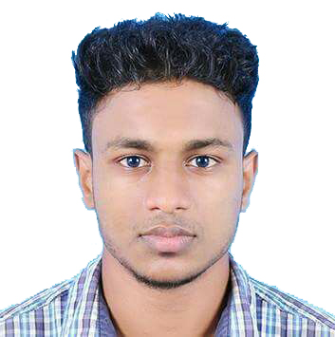
CURRICULAM VITAE

JUNAID.M

IND mob:+919895653742
E-mail.:- Junaidm323@gmail.com
Objective

Seeking a position to utilize my skill and abilities in the challenging areas of firm that offers professional growth while being resourceful, innovative and flexible.
Educational Qualification

- VHSE [Agriculture] from Board of VHSE Kerala
- S.S.L.C from Board of Public Examinations.
- AGRICULTURE DIPLOMA
Computer Knowledge

- MS Office & Internet etc..
Experience

- Safari Company (25th may 2017 to May 25th 2021)
Presently working CHIEF OF AGRICULTURE SECTION PEST CONTROL & LANDSCAPE SUPERVISOR in KSA (Safari.pvt Company)25th may 2017 - To may 25th 2021)
Duties & Responsibilities
- Preserved the quality and cleanliness of grounds through grass cutting, hedge trimming weeding and leaf cleaning.
- Operate Vehicles, Equipment and machinery in compliance with health and safety regulation.
- Performed seasonal tasks
- Executed general gardening duties
- Opened and closed the premises, maintaining exceptional levels of securities.
- Managed tool, equipment and materials inventory, employing and to guarantee constant availability.
- Promptly completed additional tasks, working flexibly outside normal contractual hours when required.
- Handled overall responsibility for grounds, building and equipment care and maintenance
- Maintained a professional and safe environment by leaving working areas immaculately clean and tidy.
- Punctually opened and closed communal areas to ensure smooth running to site
- Implemented preventative maintenance programmed
- Implemented schedule for maintenance of facilities to meet targets and perform to deadlines.

2-Kerala Agricultural University-Anakkayam.
On the job training programmed at Kerala Agricultural University Anakkayam from 15-11-2011 to 30-11-2011

KEY SKILL

- Excellent communication and public speaking skills
- Good command over basic computer operation
- Under stand in work in any testing circumstance

Extra-Curricular Activities

- Divining - Saudi Driving License
- Good grasping and analytical skills.
- Hard- working and sincere.
- Positive attitude
- Self Confidence.
- Weekly assembly, monthly meeting

Personal Data:

Name of father :Aboobacker.M
Name of mother :Ramla.T.K
Date of birth :17th Jan 1995
Sex :Male
Nationality :Indian
Religion & cast :Islam, Muslim
Marital status : married
Passport No. : M1570545

Language Known:

English, Malayalam, Hindi,arabic
Core Strength:

Punctuality, Dedication to work, Communication skill, Creative thinking, Value self positively.
Hobbies:

Gardening, Travelling & Reading
Declaration:
I hereby declare that the above information is true to the best of my knowledge and belief.

Junaid. M
Date: 15-03-2021

