CURRICULUM VITAE

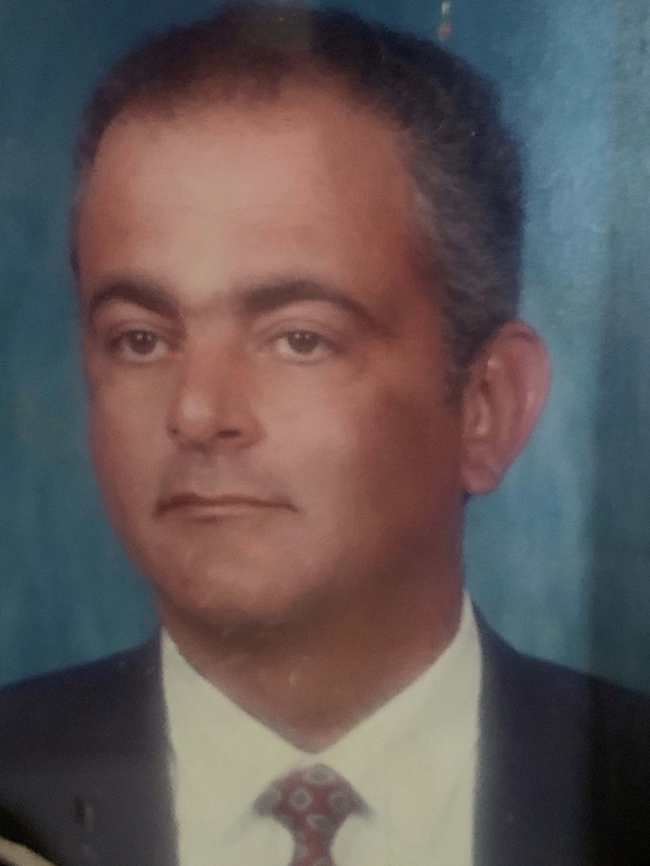
WADDAH EMAD EL RAMLY
CIVIL ENGINEER

Nationality : Jordanian

BORN: September 1957
LANGUAGES: Arabic, English

EDUCATION: Bachelor of Science - Civil Engineering, Cairo University, Faculty of Engineering, 1980.

Mobile Tel. : +966558070878

e-mail address : waddah.elramly@hotmail.com

PROFESSIONAL EXPERIENCE:

- Dec. 2006 to Present
Dar Al Handasah Consultants, Projects in Western Region

Responsible for the supervision of site works, including coordination of site activities among various engineering disciplines, ensuring compliance of works with the approved specifications and quality plans, preparation of progress reports, evaluation and approval of submittals, resolution of site problems, liaison with different project parties, overseeing the handing over of executed works, etc., for the following projects: - King Abdullah Bin Abdel Aziz Extension for the Holy Haram, Saudi Arabia. Supervision of construction for an extension to the Makkah Holy Haram to accommodate additional 800,000 worshipers, comprising a new building of 4 praying levels with a capacity of 300,000 worshipers, connected at its ground, first and roof floors to the First Saudi Extension of Makkah Haram, and includes a basement level for electromechanical services; state-of-the-art technology in natural and artificial climate and lighting controls; security, crowd management, and sound distribution and control systems; structural health monitoring sensors; cleaning equipment; interactive signage; and high end interior finishing works. The project provides internal courtyards covered with 12 operable skylights, 6 fixed ones, 4 fixed domes of 18 m diameter each, and one 36 m diameter sliding dome above the 24 m wide and 26 m high ceremonial spine connecting the north and south piazzas through a 59 m wide main gate at the north end flanked by 2 new minarets (135 m high each) on its left and right sides and a 30 m wide gate at the south end. The project also comprises 194,000 m² external praying piazzas accommodating 314,000 worshipers with 2,500 toilet cubicles and 850 ablution points beneath them; a service building of 6 overlapped radial steps accommodating 8,750 toilets, 5,370 ablution points, 2 helipads, service and solid waste management facilities, authorities’ offices and a 110,000 m² praying area at its roof level for 165,000 worshipers; several bridges (total of 42,750 m²) linking the new building to the service building and to the existing Holy Haram; a service road below the external piazzas and dedicated service culverts carrying all infrastructure utility networks. - Islahiyat Buildings, Saudi Arabia. Design review, review of shop drawing and material submittals, project management and supervision of construction for 4 sites of 1.575 million m² each in Jeddah, Riyadh, Dammam and Taif. Each site consists of 155 buildings (total built-up of 190,000 m²), serving 7,272 prisoners and including detention and correctional facilities, housing units, schools, clinic, administration buildings, workshops, and infrastructure utilities networks from start of project up to testing, commissioning and handing over. • Design and Built Infrastructure Project at Bay La Sun Residential and commercial area in King Abdul Aziz Economic City Rabigh • Design and Built Jeddah Cable Project in Rabigh of new Jeddah cables complex Buildings Turn Key Project. • Design and Built of Jamarat Bridge Mega Project, Jamarat Bridge • Plan and Implement Projects Contract Documents through evaluation of construction projects methods statements and determine the best engineering method or practice to accomplish the job, establish an estimated cost and what tools and technologies are appropriate for the job as well as a timeframe for the work to be completed. • Supervise Projects Supervising construction staff to ensure staff are properly trained in the use of all tools of Specifications, Drawings, Standards, equipment, that all staff have access to and use any safety gear and that the team is reaching the required milestones. To resolve any Technical issue that might face the construction crews and to evaluate the issue and provide the appropriate solutions. • Oversee Compliance to make sure our projects adhere to all government and industry standards and guidelines. If special permits or records need to be obtained, we will do so and ensure the paperwork is recorded and controlled properly. • Provide best services and ensure client satisfaction. • Ensure in compliance with company policies and practices • Ensure the Smooth operation from Site Handing over of Project to Successful
- From Jan 03 to Nov 06

Al-Saad Contracting & Trading Co.

Project Manager

Working as Project Manager for General Security Training City Project In MEKKAH consists of Dormitories , Mess Hall educational Buildings, respective Infrastructure Utilities and Roads Project value of 40 million SR and Built up Area of 30,000 sq. meters .

- From Oct 92 to Jan 03

Saudi Binladin Group – IPP BEMCO

Project Manager

      - Moving of Bemco Warehouse and Factories to S.B.G Industrial City in Jeddah of Project Value: SR 6 million.

      - Design and Built of 110/13.8 K.V Marwa Substation Civil Works Project Project Value: SR 10 million.

Civil Construction Manager
      - Riyadh Power Plant No. 9 – 1286 MW Combined Cycle , Civil Works of Turbines Foundations , Power Plant Halls and audited successfully for I.S.O 9001during this Period The Project value : 10OO million SR.

4 – From Aug 85 To Sept 92
Dar Al Handasah Consultants

Civil Engineer

Supervision and technical advise as member of consulting team for the following projects:

- Part of technical support team as site inspector for a 600 meter long Jeddah Diwan Underpass – Jeddah
- Head of 2 surveying teams for investigating and surveying all underground services (Telephone, electricity, sewage, water and other) that are interfacing with extension of the Holy Haram – Makkah
- Madina Entrance Project – As a part of consultancy team as Civil Engineer for 3 no. entrances including bridges and underpass of total 26 kilometers and reporting to the client.

5 – From Feb 80 To Jul 85

Pegal Arabia ( Part of Sogex International )

Civil Superintendent

Worked as Civil Superintendent in Terminal Buildings Complex TRI-TR2-TR3 & TR4 of King Khalid International Airport at Riyadh.
Project Value: SR 350 million per terminal.

