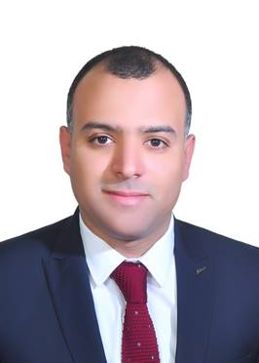
Curriculum Vitae

Personal data:
Name: | Moaaz Nageh Mahmoud Abdullatef
Date of Birth: | 24/6/1986
Social status: | Married
Military service: | Postponed
Mobile1: | 0505491463
Mobile2:
E-mail: | mouaz.nageh@gmail.com
Education: | Graduate of the Faculty of Social work

Career Objective:
Seeking a challenging representative position in a professional organization.
Experience:
KSA:
Working with Rezayat Co. Ltd on the Royal Commission Project as Document Controller since 5/2021 till now.
Working with Rezayat Co. Ltd on the sadara chemical company Project as Document Controller since 4/2019 till 4/2021.
Working with Rezayat Co. Ltd on the Petro Rabigh Project as ID Admin since 11/2017 till 3/2019:
PRC ID Vehicle Sticker Heavy Equipment Sticker
Working with Rezayat Co. Ltd as Maintenance planner since 9/2017 till 11/2017.
Egypt:
Working as back office team Leader in FX stations Company SMART TRADING, since 11/2015 till 7/2017.

Working as Marketing Research on Social Media in FX stations company SMART TRADING, since 7/2015 till 10/2015

Working in Te data customer service agent since 1/2015 till 6/2015.

Working in Vodafone Egypt customer service agent 11/2013 till 12/2014.

Working as sales in Raya Electronics Company since 1/2012 till 5/2013

Responsibilities:

- Manage and priorities team work schedules to ensure upload targets are met seamlessly on a weekly basis.
- Collaborate with managers in achieving daily activities.
- Establish targets to monitor both team and individual performance and track success.

Soft Skills:

- Highly Communications Skills.
- Ability to work in a group or individually according to the job requirements.

Language skills:

Good Command of ENGLISH Spoken and written.
Certificate:
- Intel Learning Program.
- ICDL certificate – Successfully passed all the units required to obtain an International Computer Driving License.
- Successfully completed the requirements of multimedia-based diploma on KiT Education Center with this details:
- Introduction to 3D Max.
- Adobe Photoshop CS4.

