Curriculum Vitae
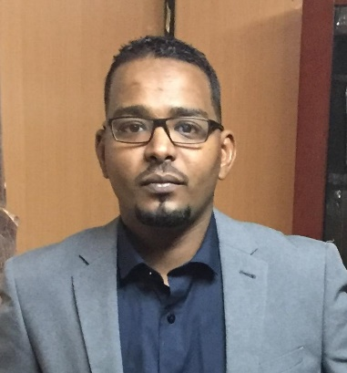

Mohanad Nassr Ali Nassr

Direct (+966504852029
Mohanadnasor707@gmaill.com

Personal particulars
Date of birth: 12/October/1985
Place of birth: KSA
Gender: Male
Marital status: Married
Nationality: Sudanese
Health: Excellent
Languages spoken: Arabic (Mother tongue)
English (good)
Languages written: Arabic / English

Education
- 1991 -1999 Primary school studies in Sudan.
- 1999 – 2002 Secondary school studies in Sudan.
- April 2002 obtained the Sudanese Secondary school certificate.
- January 2003 entered Omdurman Alahlia University .
- December 2007 graduated with a diploma degree of computer science.
Courses
- 1-1-2009 to 31-3-2009 certificate of completion from ( Cypher Information serves co.ltd)
- 23-10-2011 to 26-10-2011 certificate of social insurance from (National social insurance fund).
- 1-10-2014 to 1-11-2014 certificate of Accounting Coors Email from ( learn for computer science& languages)

Experience
- 1-7-2007 to 27-12-2007 was trained company AG Mimar Investment Services Ltd, Department of Administration.
- 13-3-2009 to 31-12-2009 Worked for CYPHER INFORMATION SERVES CO.LTD
.
- 17-9-2010 to 12/08/2013 MEGA FOOD INSUSTRIES CO LTD (ARAAK GROUP) Pepsi. HR Officer.
- 13/08/2013 – 3/8/2014 work at Khartoum Petrochemical Company HR Officer.
- 20/5/2015 – 17/10/2021 Storekeeper at Saudi BinLadin Group.
- 18/10/2021 – 27/12/2021 Warehouse coordinator five season optical.
- 24/2/2022 - work now storekeeper at alaseel shareholding co. .

Personal Skills
Excellent team leader.-
Good working knowledge of Microsoft Office (Word, Excel and Power Point).-
- Maintenance of personnel files all staff maintenance of all employee list record
- Finger print scanners for access control and daily attendance sheets.
- By high ability to deal with the staff of the practical reality in the administrative affairs.
. Contact information
Mobil phone: 00966504852029.
Email: mohanadnasor707@gmail.com

