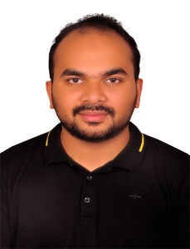
Sunaid Kunhammed
INSTRUMENTATION ENGINEER
E-mail : sunaidkunhammed@gmail.com
Mobile–: +971-521670566, +966-562724195
Resume Summary
Proficient Instrumentation Engineer with almost 5 years of experience driving over various positions to execute Projects & Sales.
Experience Summary

Instrumentation Engineer
Highscope Engineering FZC, Sharjah, UAE
July 2017 to 2021

Instrumentation Project Engineer for Process Packages
- Preparing Engineering Documents
- Procurement of E&I materials
- Handling Technical Support
- Supervising Instrumentation installation at site
- Handling FAT & Inspection

Instrumentation Engineer – On Contract
National Oilwell Varco, Dubai, UAE
Nov 2018 to Feb 2020
- Preparing Engineering Documents
- Closing technical bid evaluation with vendor
- Designing & Engineering of Skid Instruments

Technical Support – E&I
Highscope Engineering KSA, Al Khobar, KSA
Current

Sales & Technical Support Engineer
- Creating new costumer and developing relation.
- Developing Business in new region.
- Creating vendors and developing relation.

Major Type of Packages Handled
- Produced water treatment Package.
- Desander Hydrocylone Package.
- GDU Package.
- Nutshell Filter Package.
- Desalter & Dehydrator Package.
- Chemical Injection Package.
- IGF Package

Educational Qualifications

Bachelor of Technology in Electronics and Instrumentation – May 2017, BSA Crescent University Chennai.

Personal Information
Father’s Name Kunhammed
Sex Male
Marital Status Married
Nationality Indian
Date of Birth 16th May 1994
Languages Known English, Hindi and Malayalam
UAE Driving License Yes
Visa status UAE Employment Visa (Transferrable)

Place: Dubai (Sunaid k)

