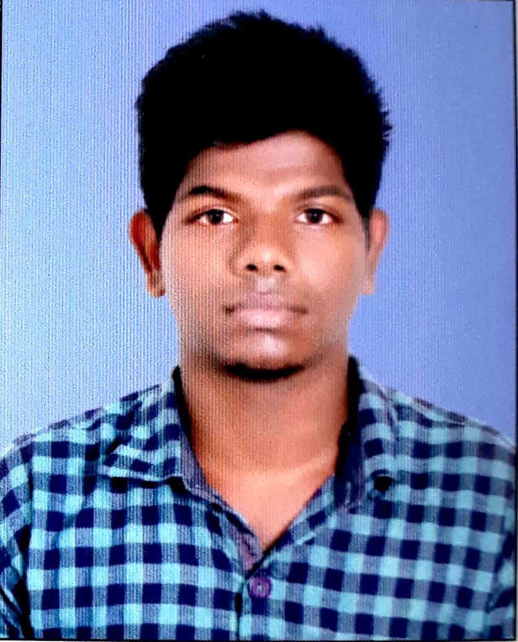 |  | manjith m.g  PLANT ATTENDER/WORKER
Profile  Plant Attender having More Than four year of plantworker and plant attender.  Contact  PHONE:  +91 9061265997  +91 9074030055  EMAIL:  Manjithmg369@gmail.com  Hobbies  Plant working  Cricket  Travel  Photography  Languages KNOWN  English  Malayalam  Tamil  Hindi  Personal Details  NATIONALITY: Indian  RELIGION: Christianity  MARTIAL STATUS: Single  DATE OF BIRTH: 09-03-1997  TECHNICAL SKILLS  Proficient in MS Office (MS Word, MS Excel, MS PowerPoint) All Major Internet Applications. |  | EDUCATION  ANNAMALAI UNIVERSITY,TAMILNADU  From 2017–To 2020  [BA-SOCIOLOGY]  JANARDHANAPURAM HIGHER SECONDARY SCHOOL  From 2012–To 2014  [HIGHER SECONDARY EDUCATION]  JANARDHANAPURAM HIGHER SECONDARY SCHOOL  TILL2012  [HIGH SCHOOL EDUCATION]  WORK EXPERIENCE  MILMA DIARY TRIVANDRUM-PLANT ATTENDER  From November 2015  More Than four year have plant work having knowledge of plantworker and plant attender.  Skills  Having Knowledge Of plant work and product sales  Having Knowledge Of mechine cleaning and floor cleaning  why me?  Understanding and performing the work with passion and responsibility.  Quick learner able to work independently.  -MANJITH M.G

